# State-Level Daily Maximum Temperature Responses to Climate Change

Kenneth L. Cox, Xiang Gao, Jennifer Morris, C. Adam Schlosser

## Abstract

Though average global temperature is expected to continue to rise into the near future, not all areas will experience the same temperature changes. Understanding which regions of the United States will undergo more warming than others is crucial for adaptation and response measures. The daily maximum temperature is an important metric for such activities because it strongly correlates to human health and economic outcomes. In this study, we analyze average monthly maximum daily temperature across all states in the United States and extract the trends for each month using linear regressions. Comparing which areas and months are experience stronger warming trends, we find the distribution is highly heterogenous, with no state in February and May experiencing any significant warming while most states do in September. Over the course of the year, New Mexico, Vermont, and Utah warm the most overall. We further analyzed a subset of variables, including moisture indices and regional information, to determine which, if any, could explain the observed distribution of warming trends. We found several weak associations in moisture and meteorological variables but conclude overall that further work is necessary to understand the correlates and drivers of these trends in maximum temperature. This work assists in identifying the highest-risk regions to near-term warming, enabling policymakers to triage those states that will experience the most drastic temperature increases.

Table of Contents

State-Level Daily Maximum Temperature Responses to Climate Change 1

Abstract 1

Introduction 1

Methods 3

Results 4

*T*max, monthly Trends Show Spatial and Seasonal Heterogeneity 4

Trends Identified with MERRA2 Data are Consistent with ERA5 Data 10

A Web App for Visualization of Average Monthly Maximum, Mean, and Minimum Temperature Trends 12

Discussion 14

Appendix 15

Sensitivity of Clustering Results to the Number of Clusters 15

Regression Validations 17

ERA5 Regression Results Over the Full ERA5 Timeframe 19

References 21

## Introduction

Global temperature increase as the result of anthropogenic climate change is projected to drive local increases in daily minimum temperature (*T*min), daily mean temperature (*T*mean), and daily maximum temperature (*T*max) (Collins et al. 2013). In turn, these increases have wide-ranging effects on ecosystems (García et al. 2018), electricity usage and the electrical grid (Molina et al. 2023; Gao, Schlosser, and Morgan 2018), and crop productivity (Wheeler et al. 2000), among other areas. Understanding how increases in global temperature relate to increases in local temperature is necessary for mitigating the impact of these changes. Moreover, since predictions of global temperature increases carry uncertainty (Lee et al. 2023), it is also important to factor in this uncertainty into predictions at the regional level, and to account for uncertainty originating in policy decisions by analyzing regional temperature responses under different emissions scenarios.

Past analyses of the connection between global and local temperature trends have heavily used global climate models, or GCMs (King 2019). This approach is advantageous for determining the physical basis of local temperature trends and for creating more robust predictions of future trends. Much of the work in this area has concentrated around extreme events, such as heatwaves, which are anticipated to grow in frequency and severity in the United States (Meehl and Tebaldi 2004). Another important area of focus aside from singular extreme events is how the day-to-day experience of temperature will change, which has direct effects on quality of life. GCMs have been useful here too, finding that the distribution of daily maximum temperature in most parts of the United States is trending towards higher temperatures (Scherer and Diffenbaugh 2014), and that for certain SSPs, a new climate normal will emerge, with regional historical high temperatures being matched or exceeded on a yearly basis (Zittis et al. 2024).

Alternatively, historical sources of data combined with reanalysis, such as MERRA2 and ERA5, have also been used to substantiate past temperature trends and suggest future outcomes. Many reanalysis data sources contain high-resolution records over time periods long enough to capture anthropogenic forcings, making them ideal for studying local responses to global temperature trends (Fujiwara et al. 2017). Tavakol, Rahmani, and Harrington used NCEP-NCAR reanalysis data to analyze trends in high temperature extremes and heat waves in the Mississippi River Basin, finding spatially heterogenous increases in 90th percentile daily maximum temperature and heat wave duration and frequency (2020). Another US-wide study, comparing across multiple reanalysis data sources, found significant increases in maximum daily temperature during the summer months outside the Midwest, as well as country-wide increases in the variance of mean daily temperature (Grotjahn and Huynh 2018). Additionally, multiple regional-only analyses have been done, including for the Northeast (Hayhoe et al. 2008), Southeast (Powell and Keim 2015), and Midwest (Dai et al. 2016).

We aim to complement these past studies with a complete analysis of temperature trends in all US states over each month. Using MERRA2 reanalysis data, we relate changes in average maximum daily temperature for each month and state in the United States to global temperature changes over the same period through linear regression models. Based on these historical trends, we generate predictions for future warming under a business-as-usual and policy scenario, with data derived from the MIT Earth Systems (MESM) model. We also conduct a Mann-Kendall trend analysis, a standard test of time-series monotonicity in the literature (Almazroui and Şen 2020), to compare with the findings of our approach. As a further test of the robustness of our analysis, we replicate our methodology with ERA5 reanalysis data. Finally, we introduce a web-based tool that enables users to explore the past and predicted future evolution of *T*max, *T*min, and *T*mean for individual states.

## Methods

A time series of yearly global average temperature (yearly *T*mean) was constructed by first taking the area-weighted global average of the daily average temperature at 2m instrument (T2MMEAN) in the MERRA2 reanalysis dataset (Global Modeling and Assimilation Office 2015) and averaging over all days in each MERRA2 year from 1980-2022. Given that one of our goals was to extrapolate trends out to the near future, we settled on using the yearly average global mean temperature as the predictor because it is the temperature variable returned by MESM.

Maximum daily temperatures averaged over each month (*T*max, monthly) from 1980-2022, for each state in the US (in addition to Puerto Rico and the Northern Marianas Islands), were regressed against the global average temperature for the corresponding year, producing 12 regressions per state. To eliminate artifacts arising from the different scales of the predictor and the outcome variables, we separately standardized the two time series variables using

$$X_{norm}=\frac{X-μ}{σ}$$

where μ is the mean of the timeseries (either the monthly-averaged daily maximum temperature or global yearly mean temperature) and σ is the standard deviation of the timeseries. The slopes produced by this regression procedure represent the covariance between the two time series. Because it is more common to interpret trends in terms of absolute warming or cooling, the slopes are converted back into the original coordinate system, where they represent average temperature change per year in degrees Celsius, as follows:

$$\hat{β}={\hat{β}}_{norm}×\frac{σ_{y}}{σ_{X}}$$

where σX denotes the standard deviation of average global yearly temperature and σy denotes the standard deviation of monthly-averaged maximum daily temperature. Whenever sloped are reported, they are in the original units (degrees of local warming per degree of global warming) unless otherwise indicated.

To visualize the uncertainty in the individual regressions, we use a Monte Carlo procedure to compute the upper and lower bounds of the entire regression model, including uncertainty from the temperature projections. Future projections of yearly *T*mean from MESM, of which there are 400, are standardized using the approach above and fed into the standardized regression model. This accounts for uncertainty in future global average temperature. To account for uncertainty in the regression model, 400 samples of the slope and intercept are drawn from the normal distribution described by the standard error of the mean and standard error of the intercept, both with mean 0. This approach results in the generation of three vectors of shape 400x1, one each for the slope, yearly *T*mean predictor, and the intercept. For every regression, the same vectors for slope and intercept are used (i.e. the samples are only drawn once, so they are not different each time). The corresponding 400 local temperature predictions are then computed using

$${\overset{⃑}{T}}_{local, year}={\overset{⃑}{\hat{β}}}_{slope}*{\overset{⃑}{T}}_{MESM, year}+{\overset{⃑}{\hat{β}}}_{intercept}$$

where $*$ denotes element-wise multiplication of the vectors. Finally, these standardized results are converted back into the original coordinate system. Repeating this for each year (again using the same vectors ${\overset{⃑}{\hat{β}}}_{slope}$ and ${\overset{⃑}{\hat{β}}}_{intercept}$ for each year), we produce the full time series of predictions with uncertainty.

In this paper, we focus our results on *T*max, monthly, although the webapp we will introduce can perform the same analyses for *T*mean, monthly and *T*min, monthly. There are many metrics that are fit to measure severity of extreme heat, such as 90th percentile *T*max, wet bulb temperature, and absolute maximum daily temperature. *T*max, monthly is a simple-to-interpret, useful metric that describes the upper bound of daily temperature while smoothing out some noise with the monthly aggregation.

## Results

### *T*max, monthly Trends Show Spatial and Seasonal Heterogeneity

The choropleth map in Figure 1 displays both the spatial and temporal distributions of the computed trends.

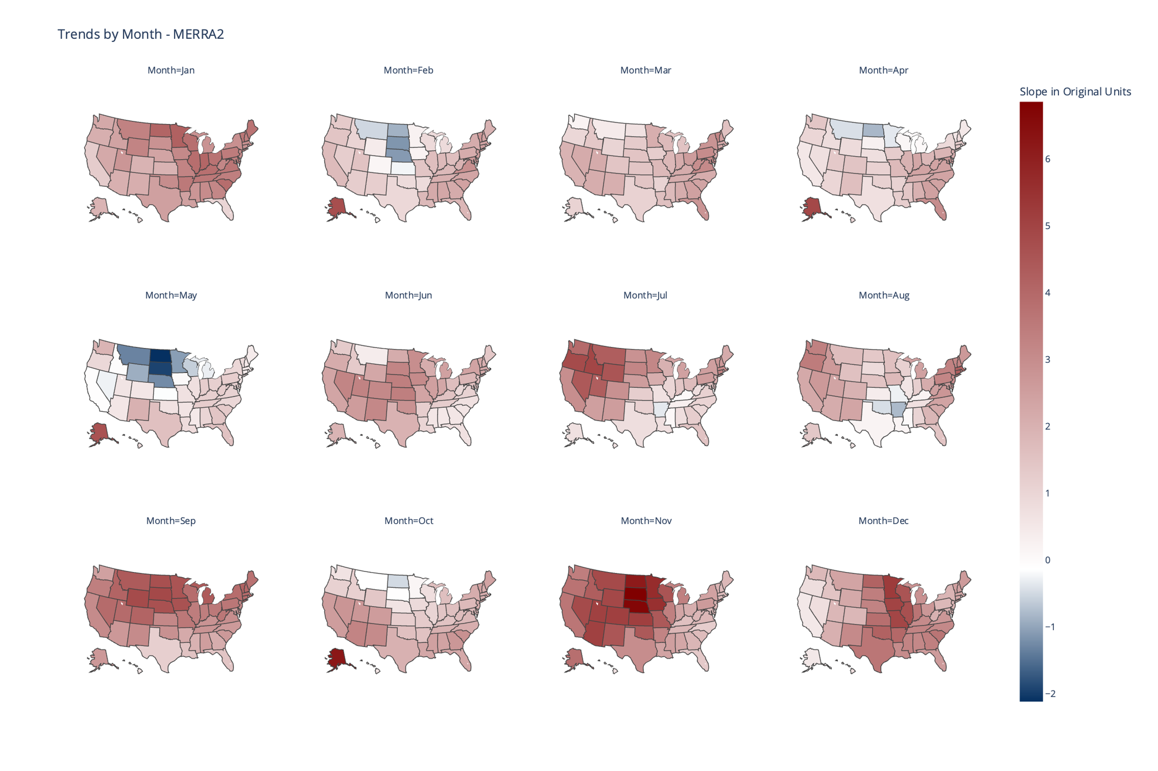

Figure . Results from a regression against monthly-averaged maximum daily temperature with global mean temperature (data from the MERRA2 reanalysis dataset). Slopes are displayed for all 50 states in units of degrees of state-level monthly-averaged maximum daily temperature per degree of global mean temperature.

The observed warming displays geographic and temporal patterns. The Midwestern states experience very small trends that even slope negative during the winter and spring months; North Dakota and South Dakota in May display the sharpest downtrend overall, with an estimated 2 degrees of cooling per degree of global warming. The weakness of the trend from January-April suggests the actual magnitude of the trend is not significantly different from 0, as statistical hypothesis testing also demonstrates [I will update the map to include statistical significance]. This is further illustrated by the individual regression plots for North Dakota in Figure 2. Although the trend for May appears to be strong, the regression plot indicates weak adherence to the trend line. In contrast, the upward trend in November is more clearly reflected by the data.

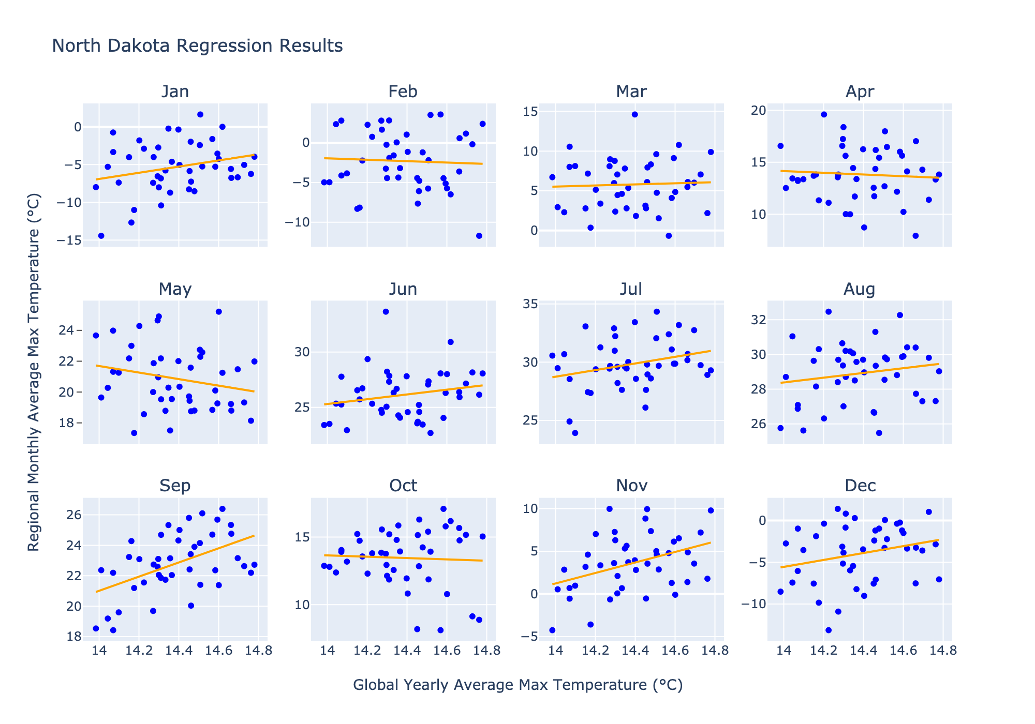

Figure . An example of the regression analysis using North Dakota. For each month, the average daily maximum temperature is obtained over a period of 43 years (1980-2022). Global mean temperature is obtained from the same time period and used as the predictor variable for a regression. The blue dots show the historical data and the orange lines show the line of best fit for the historical data.

Throughout the rest of the United States, the warming trends generally remain small but steady throughout the year. The Northeast, for example, has very mild warming trends from February – May, which then pick up in the summer months. The South has warming hovering around 2 degrees of *T*max, monthly increase per degree of average global temperature increase, without any large deviations; although the warming trend becomes indistinguishable from 0 in [save for when statistical significance plot is created].

To better characterize the spatial elements of the trends, Figure 3 breaks them down by region. The k-means clustering algorithm, a common unsupervised learning algorithm used to visualize climactic and temperature patterns (Kim and Kim 2023; Carvalho et al. 2016; Sathiaraj, Huang, and Chen 2019), was used to generate the map in Figure 3. The algorithm clustered states based on similarity in trends between months (the trend for each state was represented as a point in a 12-dimensional vector space, where each dimension corresponds to a month), and we specified the k-means algorithm to find 6 clusters. The clusters overlap somewhat with geographic regions in the US, with cluster 6 roughly corresponding to the Upper Midwest, cluster 1 corresponding to the West, Cluster 3 corresponding to the Middle Midwest, cluster 2 corresponding to the Eastern Seaboard, and cluster 5 corresponding to parts of the South and Lower Midwest. However, the correspondence in each of these cases is not exact, and Alaska did not fit neatly into any of the other clusters. Supplementary Figure 1 in the Appendix contains two additional plots where the number of clusters was set to 4 and 5, as a test of the robustness of the clusters.

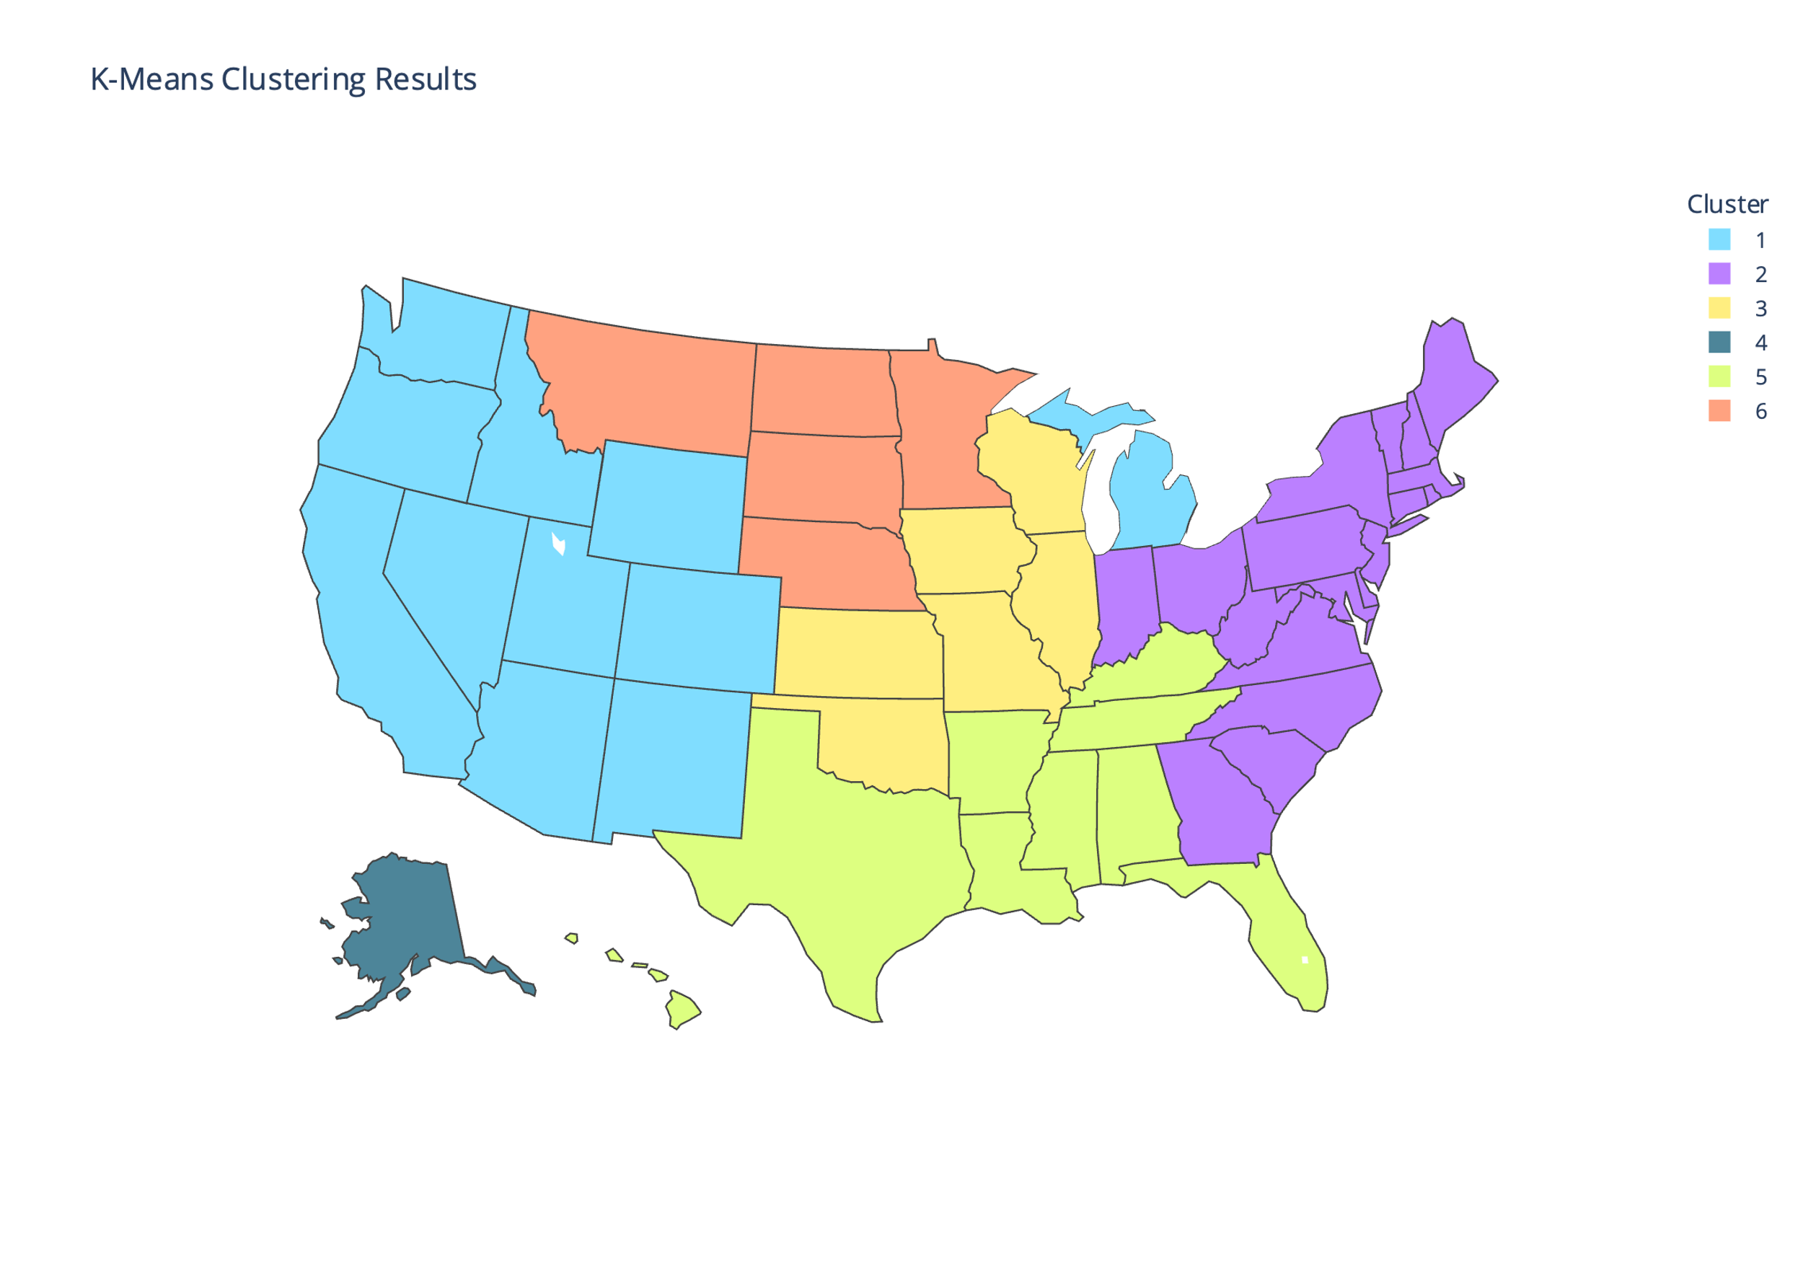

Figure . K-means clustering applied to the slopes from the regressions. Each state can be represented as a point in a 12-dimensional space, where each dimension corresponds to that state’s slope in each month of the year. The k-means clustering algorithm partitions the states into (in this case) 6 clusters based on how close each state’s slopes are to the centroid of each cluster, which is updated dynamically for each iteration of the algorithm.

The bar graph in Figure 4 displays the five states with the highest and lowest average trends. Alaska displays the highest historical warming, with an average of 2.9 degrees of monthly-averaged maximum daily temperature increase per 1 degree of global warming, while Hawaii displays the lowest historical warming, at 0.6.

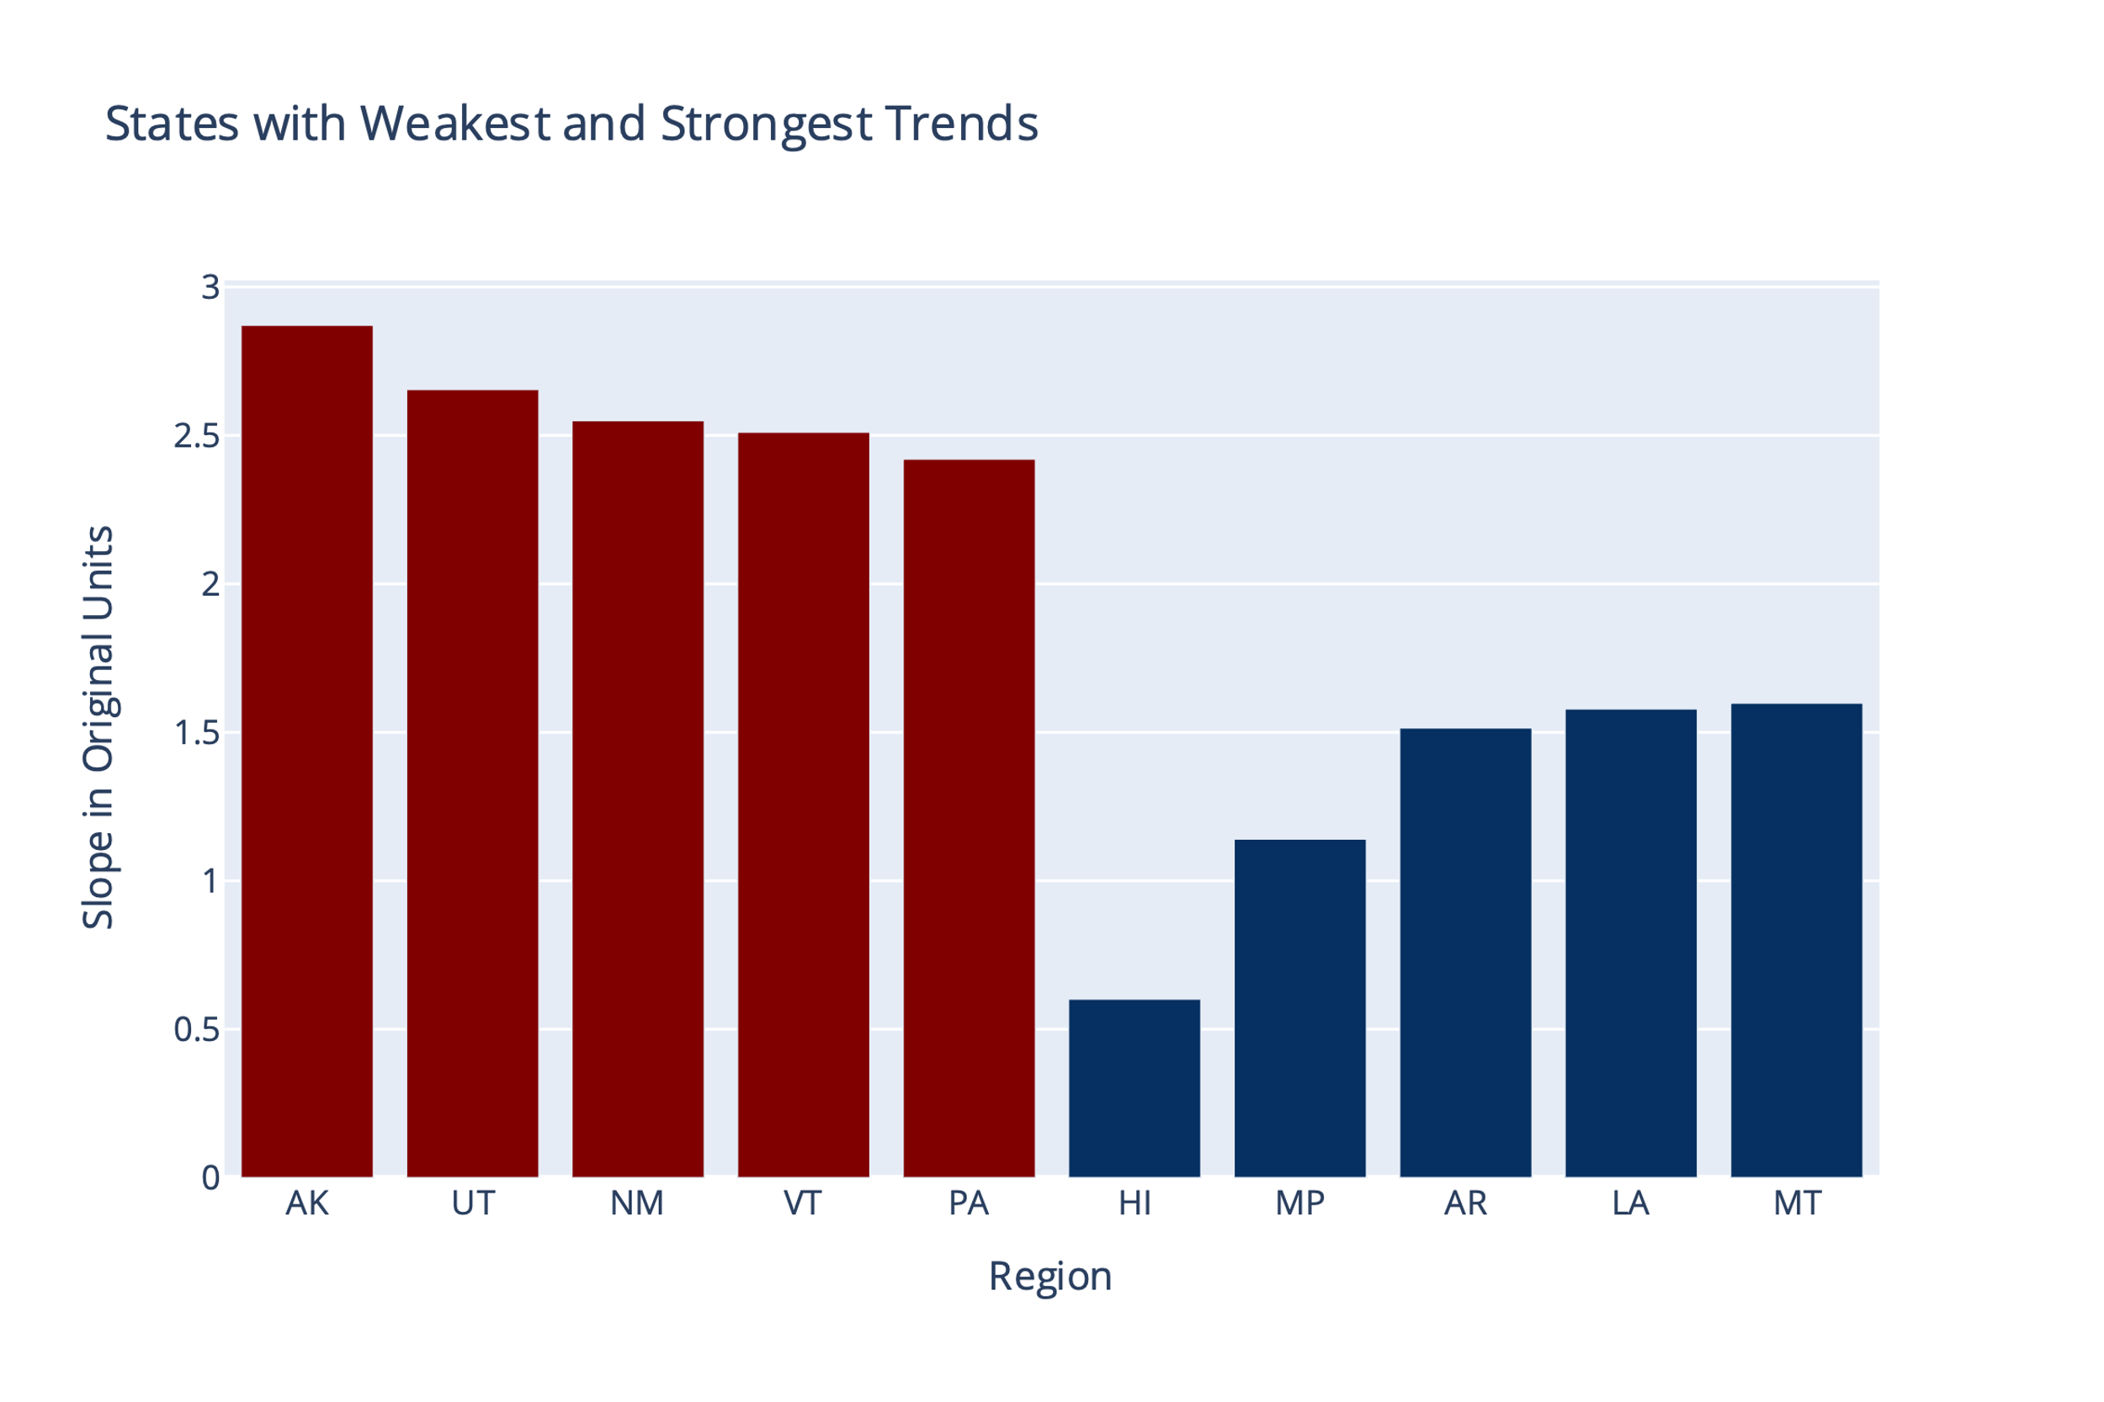

Figure . States with the largest and smallest overall warming trends on average. Alaska, Utah, New Mexico, Vermont, and Pennsylvania have the highest average slopes (in red), while Hawaii, the Northern Marianas Islands (MP), Arkansas, Louisiana, and Montana have the lowest (in blue). MP is included in the dataset (along with Puerto Rico, PR) because there are points in the MERRA2 grid that overlap with the geographic boundaries of these two territories, but the slopes of these two territories are not shown on our previous figures for clarity.

We now turn to the temporal elements of the trend. Figure 5 breaks down the distribution of trends by month. The orange lines and text in the figure show the median slopes; the largest median increase in *T*max, monthly occurs in September (3.26 degrees of local warming/degree of global warming), while the lowest occurs in May, with a median warming of 0.71 degrees/degree of global warming. Two month-to-month trends are surprising: first, a sharp drop-off in warming from January to February, and second, a warming spike in September.

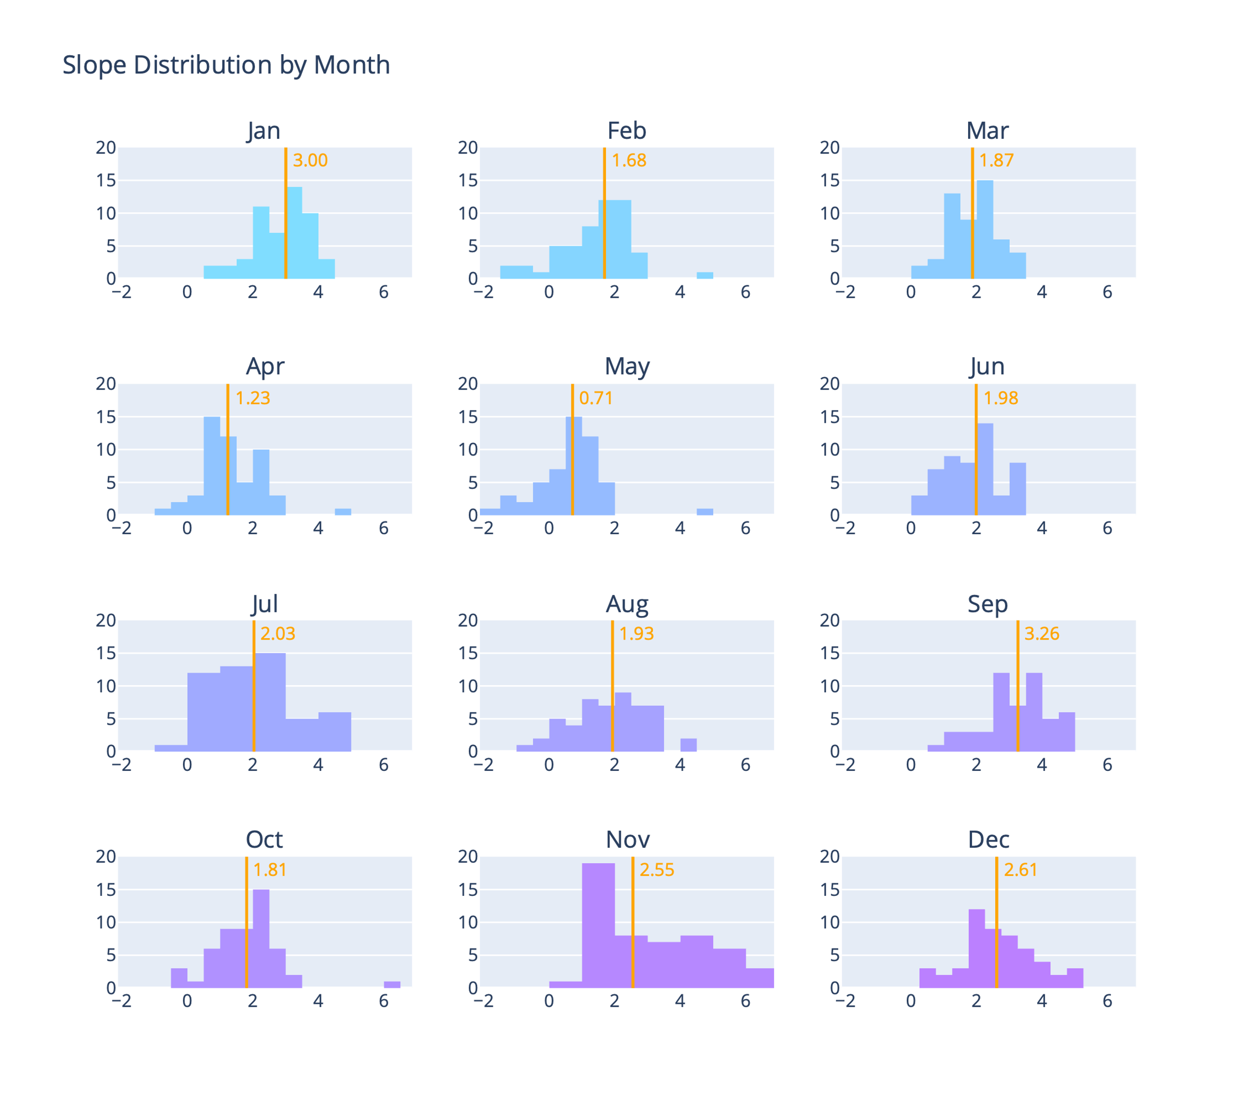

Figure . Distributions by month for the slopes of all regions (50 states, MP, PR). The orange line and text show the medians of the distributions.

To further confirm the presence of these trends, we conducted a Mann-Kendall test, a common nonparametric test of monotonic trends. As in other applications, the Mann-Kendall test of significance is paired with the Theil-Sen estimator, a nonparametric estimator of linear trends, to provide a visualization of where the strongest monotonic trends exist. The plot of the Theil-Sen estimators, with significance established by the Mann-Kendall test, is given in Figure 6 [will update plot with significance results].

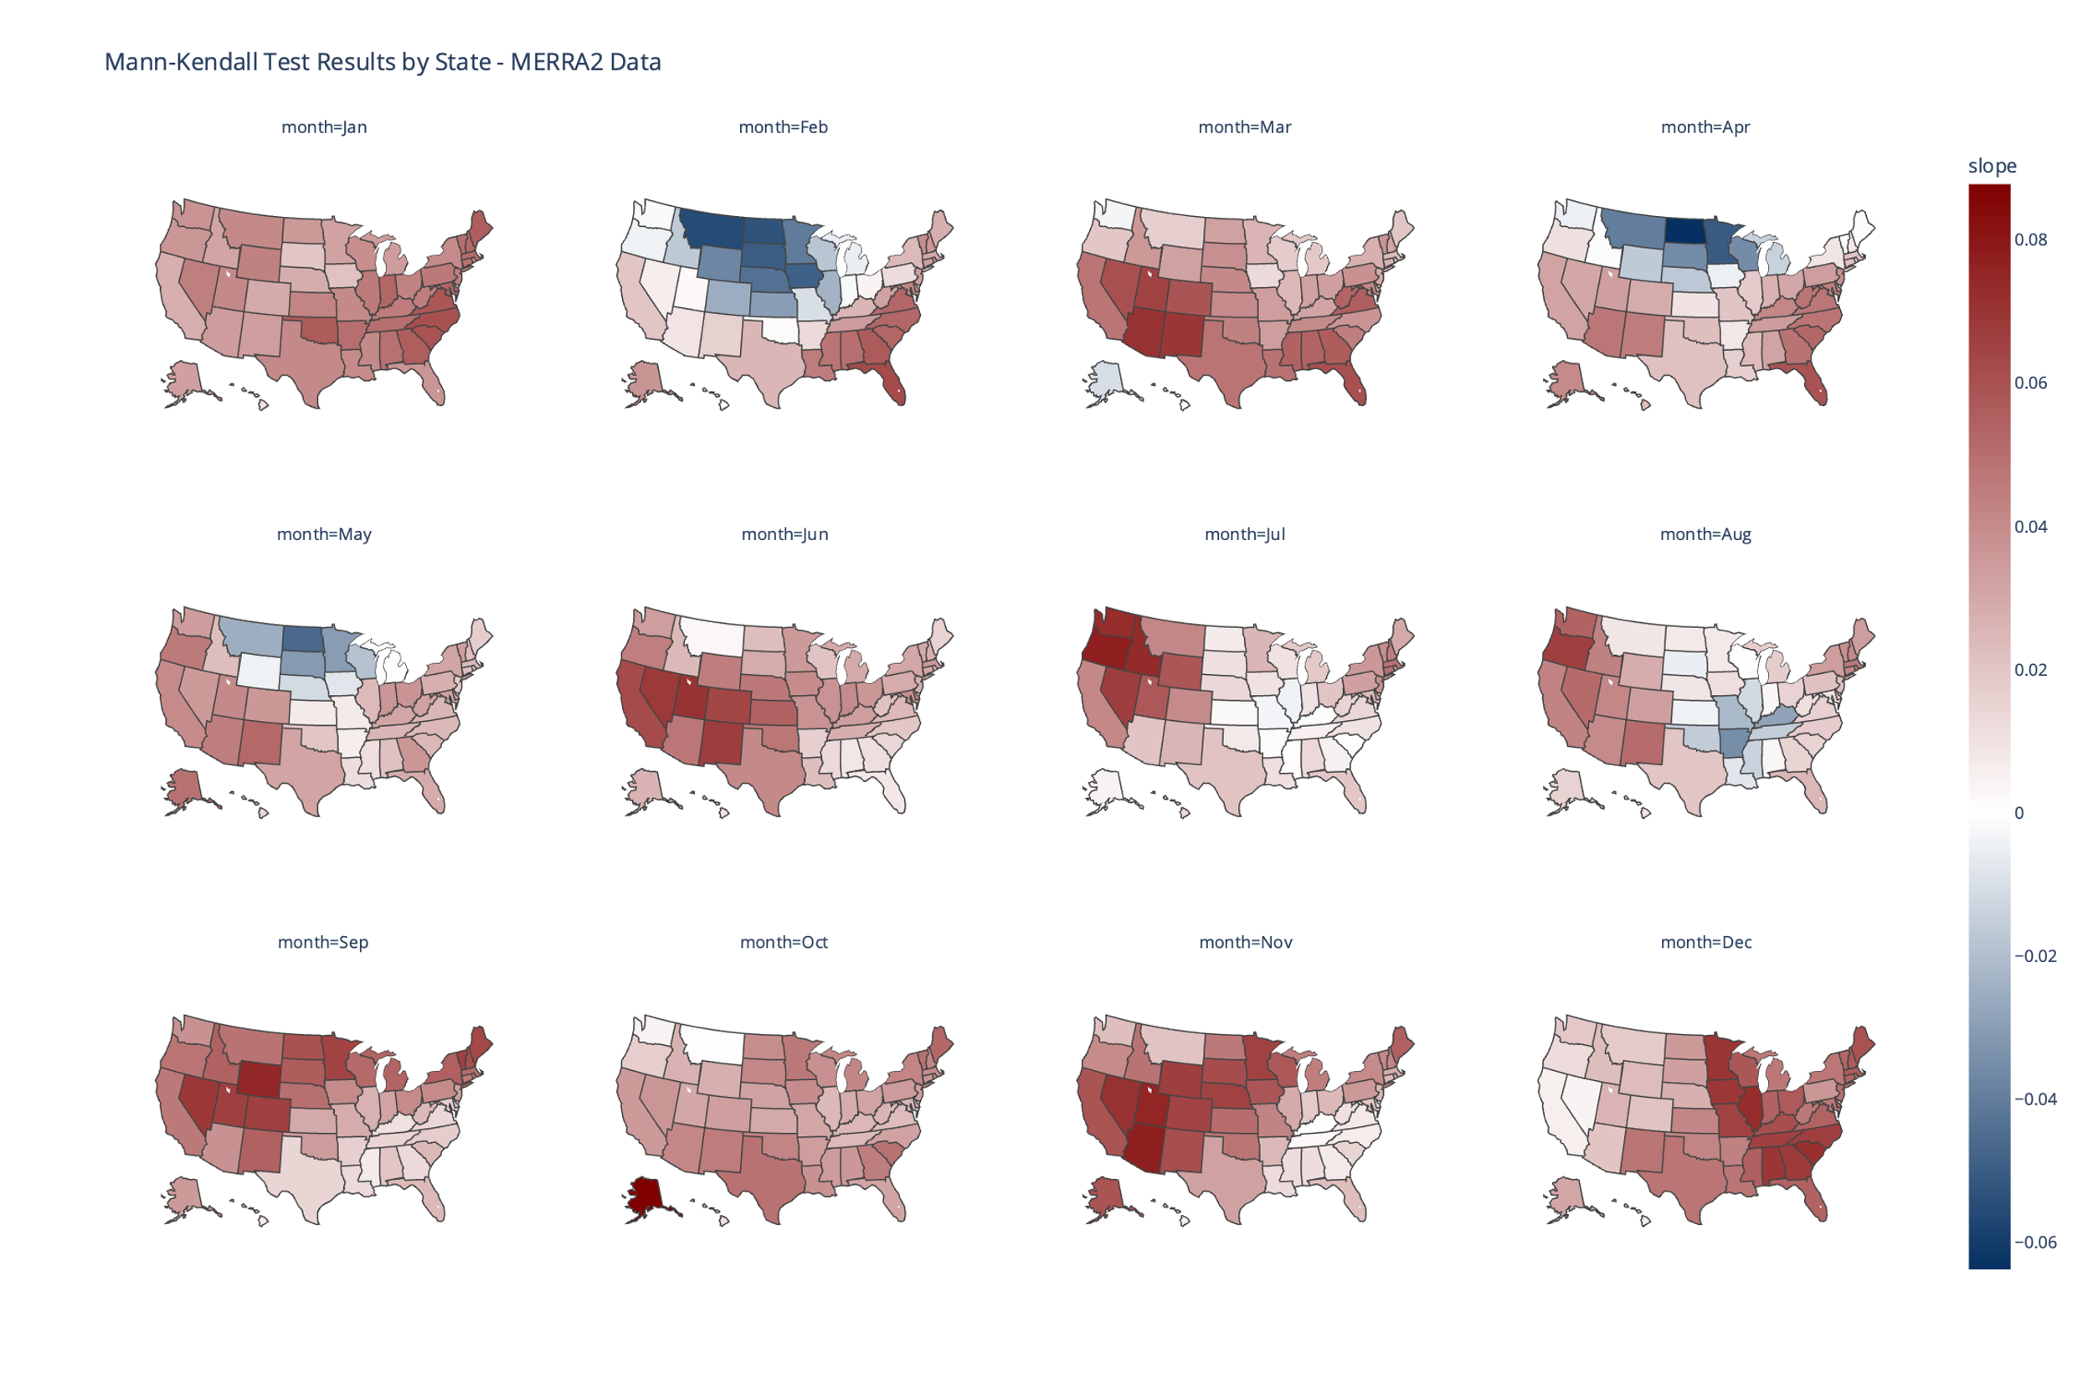

Figure . Value of Theil-Sen's estimator for the 50 states, a nonparametric test for monotonic trends. Units of slope are degrees of local monthly-averaged maximum daily temperature per year since 1980. The value of the Theil-Sen estimator is the median slope of each pair of points in the data set, (yj - yi)/(xj - xi), i ≠ j where y is the temperature variable and x is an index variable for years since 1980.

### Trends Identified with MERRA2 Data are Consistent with ERA5 Data

The choice of dataset can impact the ultimate results of the trends and observed patterns in the trends. To determine whether the findings with MERRA2 data were robust, we repeated our methodology using ERA5 reanalysis data (ECMWF 2024). Figure 7 displays the choropleth map of regression slopes over the same years as the MERRA2 data (1980 – 2022).

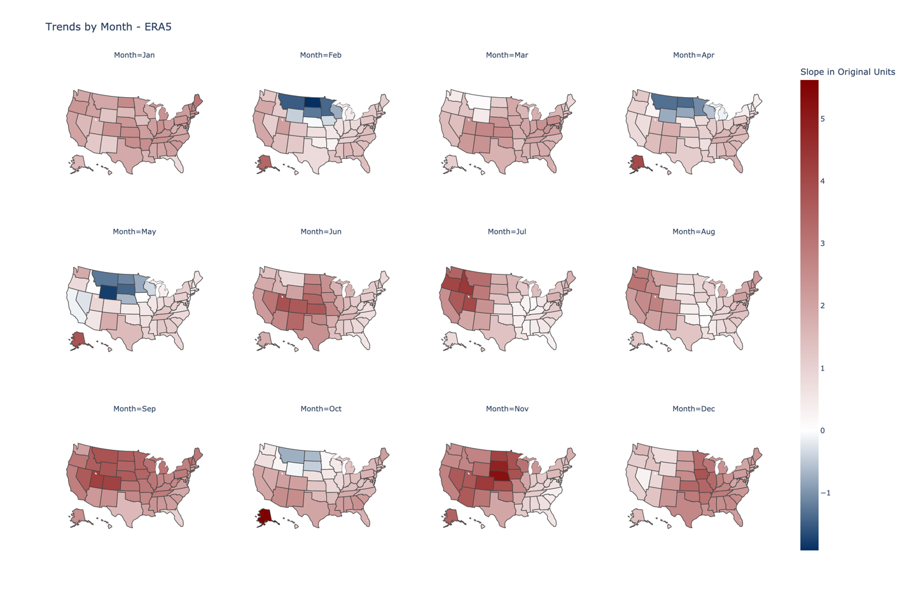

Figure . Original regression method replicated with ERA5 data for the 50 states (no territories). Although the units are the same (degrees of state-level monthly-averaged maximum daily temperature per degree of global mean temperature), note the difference in the bounds of the legend for purposes of a direct comparison.

Although the magnitude of the trends differ, the warming patterns are consistent. The warming hole in February, April, May, and October, in the upper Midwest, remains, along with the strong warming trend in roughly the same region in November. A more quantitative comparison of absolute differences in sloped between the two reanalysis data sets is given in Figure 8.

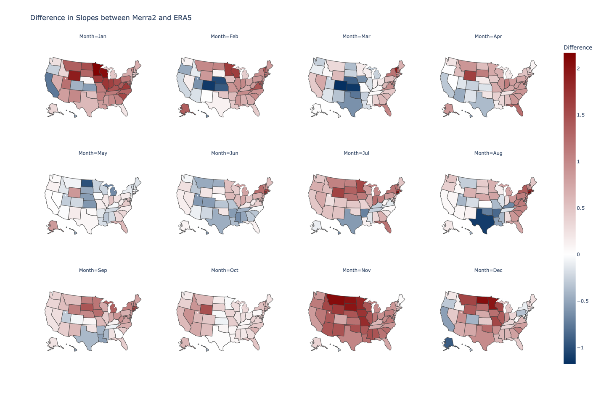

Figure . State-level differences between the MERRA2 slopes and ERA5 slopes, computed as MERRA2 slope - ERA5 slope; positive numbers indicate a larger MERRA2 slope, while negative numbers indicate a larger ERA5 slope.

Most regions have little difference between the two datasets. The month where the most differences, and the largest magnitude of differences, occur is November, in which MERRA2 returned higher slopes in every state except Hawaii. In January, MERRA2 also returned a higher slope for most states, with lower slopes only in California, Oregon, Colorado, Hawaii, and Kansas.

### A Web App for Visualization of Average Monthly Maximum, Mean, and Minimum Temperature Trends

The results presented in this paper cover overall trends in average monthly maximum temperature for the US. So far, discussion of trends for specific states, and temperature projections in specific states under different socioeconomic assumptions, have largely been absent. To enable ease of visualization of both trends and projections for each state, we present a web app, available to Internet users and without a sign-up requirement. Users can select any state and view historical and projected future temperature data under a business-as-usual scenario and aggressive mitigation scenario. A screenshot of the web app is given in Figure () [will add this as soon as I update the app with mean and minimum temperatures].

The webapp produces figures similar to Figure 2, extended to include into the near future. The projections were generated using two 400-member ensembles of the MIT Earth Systems Model (MESM), one for a business-as-usual scenario, and one for an accelerated actions scenario. The evolution of the projections of those ensembles is given in Figure 9.

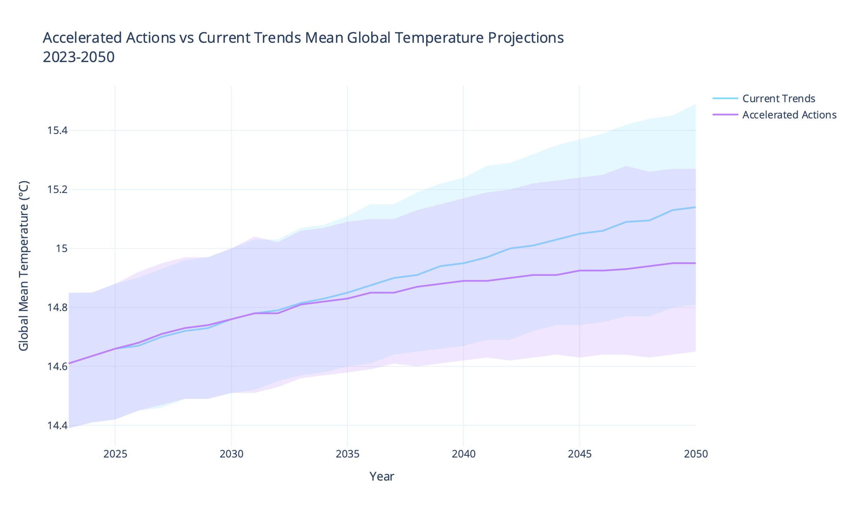

Figure . MESM projections for average global temperature through 2050 under a business-as-usual (Current Trends) and policy (Accelerated Actions) scenarios. The shaded regions correspond to the lower 5th percentile and upper 95th percentile of global mean temperature in the MESM ensembles.

To create future projections of local temperatures that accurately represent the uncertainty in both the regression coefficient and in MESM global average temperature projections, we use the Monte Carlo approach described in the Methods section. A plot like that shown in Figure 10 is produced for each state and each temperature condition (maximum, mean, minimum) and is available on the webapp.

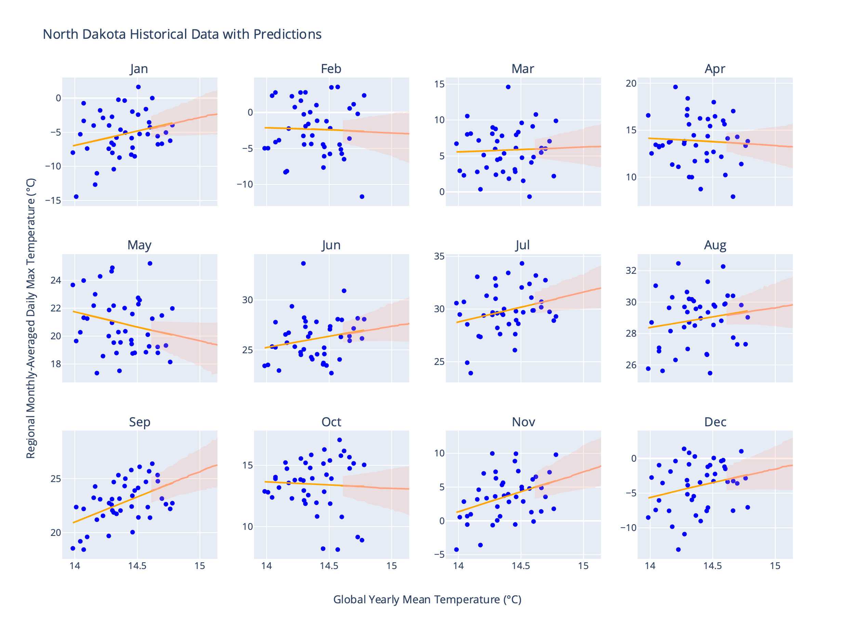

Figure . Regression results for North Dakota also showing projections for the near future (up to 2050) under the Current Trends (business-as-usual) scenario in MESM. The uncertainty bounds reflect the upper 95th and lower 5th percentiles of the projections, taking into account both uncertainty in the regression parameters and uncertainty in the yearly temperature projections.

The bounds in Figure 10 do not capture all the sources of uncertainty in the historical data. Because the regression uses only global mean temperature as a predictor variable, the variance explained in the regional temperatures is only explained by global mean temperature, excluding other factors that can affect regional temperatures. Therefore, the projections are best understood as the evolution of the trend (whether, for instance, it is likely that the trend will become negative in the near future if it is positive now), and not as a strong predictor of specific monthly temperatures. A validation analysis of the regression, showing its efficacy at predicting specific monthly temperatures, is provided in the Appendix.

## Discussion

Although the average global temperature across the world, and in the US, continues to rise, not all areas of the United States have experienced the same level of warming. Our analysis of temperature reanalysis data in the US revealed the spatial and temporal patterns of state-level average monthly daily maximum temperature change. Of note is the “warming hole” in the Midwest, which has also identified by several previous studies. In the present study, the warming hole is most prominent in February, April, May, and August, and exists mainly in the upper Midwest (drifting more towards the Southeast in August). Grotjahn and Huynh (2018), using both reanalysis and observational data during the summer months, found a primarily Midwest warming hole that varied according to the dataset used, as well as the time period covered. Our analysis of the extended ERA5 dataset (starting in 1940, available in the appendix) reinforces this finding. With 40 extra years of data, both the magnitude of the trends, and the position of trend foci such as warming holes and areas of heavy warming, vary.

The warming hole has received much attention in the literature (see Mascioli et al. 2017; Partridge et al. 2019; Meehl, Arblaster, and Branstator 2012; Partridge et al. 2018; Meehl, Arblaster, and Chung 2015). Some reports have localized the warming hole in the Southeast, while others have implicated the Midwest; the extent of the warming hole depends on the temperature metrics used, the time period studied (e.g., mid 20th century vs. late 20th century), and the aggregation used (e.g., summer vs. winter). Our results lend further support to these previous results, finding that the strength of the warming hole depends on the month (but not the choice of dataset, as the ERA5 data shows a very similar geographic pattern to the warming hole). In addition, our results show, since the elimination of the warming hole in the 1990s, the overall temperature trends in the Midwest are upward over the 1980-2022 period for most months of the year.

On the warming side of temperature trends, we find that the Western states (corresponding to Cluster 1 in Figure 3) have generally positive warming trends throughout the year. The warming of the Northeastern states and the Great Lakes region also remain relatively consistent. There is an overall strong upward warming trend throughout the US, but especially in the Midwest, in November, but this pattern is only visible the MERRA2 data – the lower trends in the ERA5 data for only November suggest an overestimate for just this one month.

A major limitation of our study is that without a physical climate model, we are unable to state with confidence how long the trends identified with historical data will continue, if at all. This is a major advantage of studies that use GCMs – for instance, Meehl, Arblaster, and Chung (2015), when studying the warming hole, were able to tie the disappearance of the (southeastern) warming hole to the positive-to-negative transition of the Interdecadal Pacific Oscillation using climate model simulations. From historical data alone, we cannot stipulate that the warming trends will continue as they are now into the near future; and since the global mean temperature only explains a small amount of the variance in *T*max, monthly (see Supplementary Figure 3), the future projections we display in this study and on the webapp should not be trusted for specific values. However, the historical data is useful for determining which individual states have, up to this point, experienced the largest increases in daily temperature.

## Appendix

### Sensitivity of Clustering Results to the Number of Clusters

In Figure 3, we presented results of a clustering analysis that enables an efficient visualization of which states contain the most similar temperature change patterns. Because the k-means algorithm used to create the clusters has random (although optimized) initialization using the k-means++ initialization algorithm (Arthur and Vassilvitskii 2006), there may be slightly different clustering results as the number of clusters is changed, and even within the same number of clusters. The randomness within the same number of clusters is accounted for by running k-means 10 times and choosing clusters based on which initial cluster centroids achieve the most stable results. The robustness of k-means with respect to the number of clusters is examined in Supplementary Figure 1, which contains clustering results using the same set-up, differing only in the number of clusters selected (4 and 5).

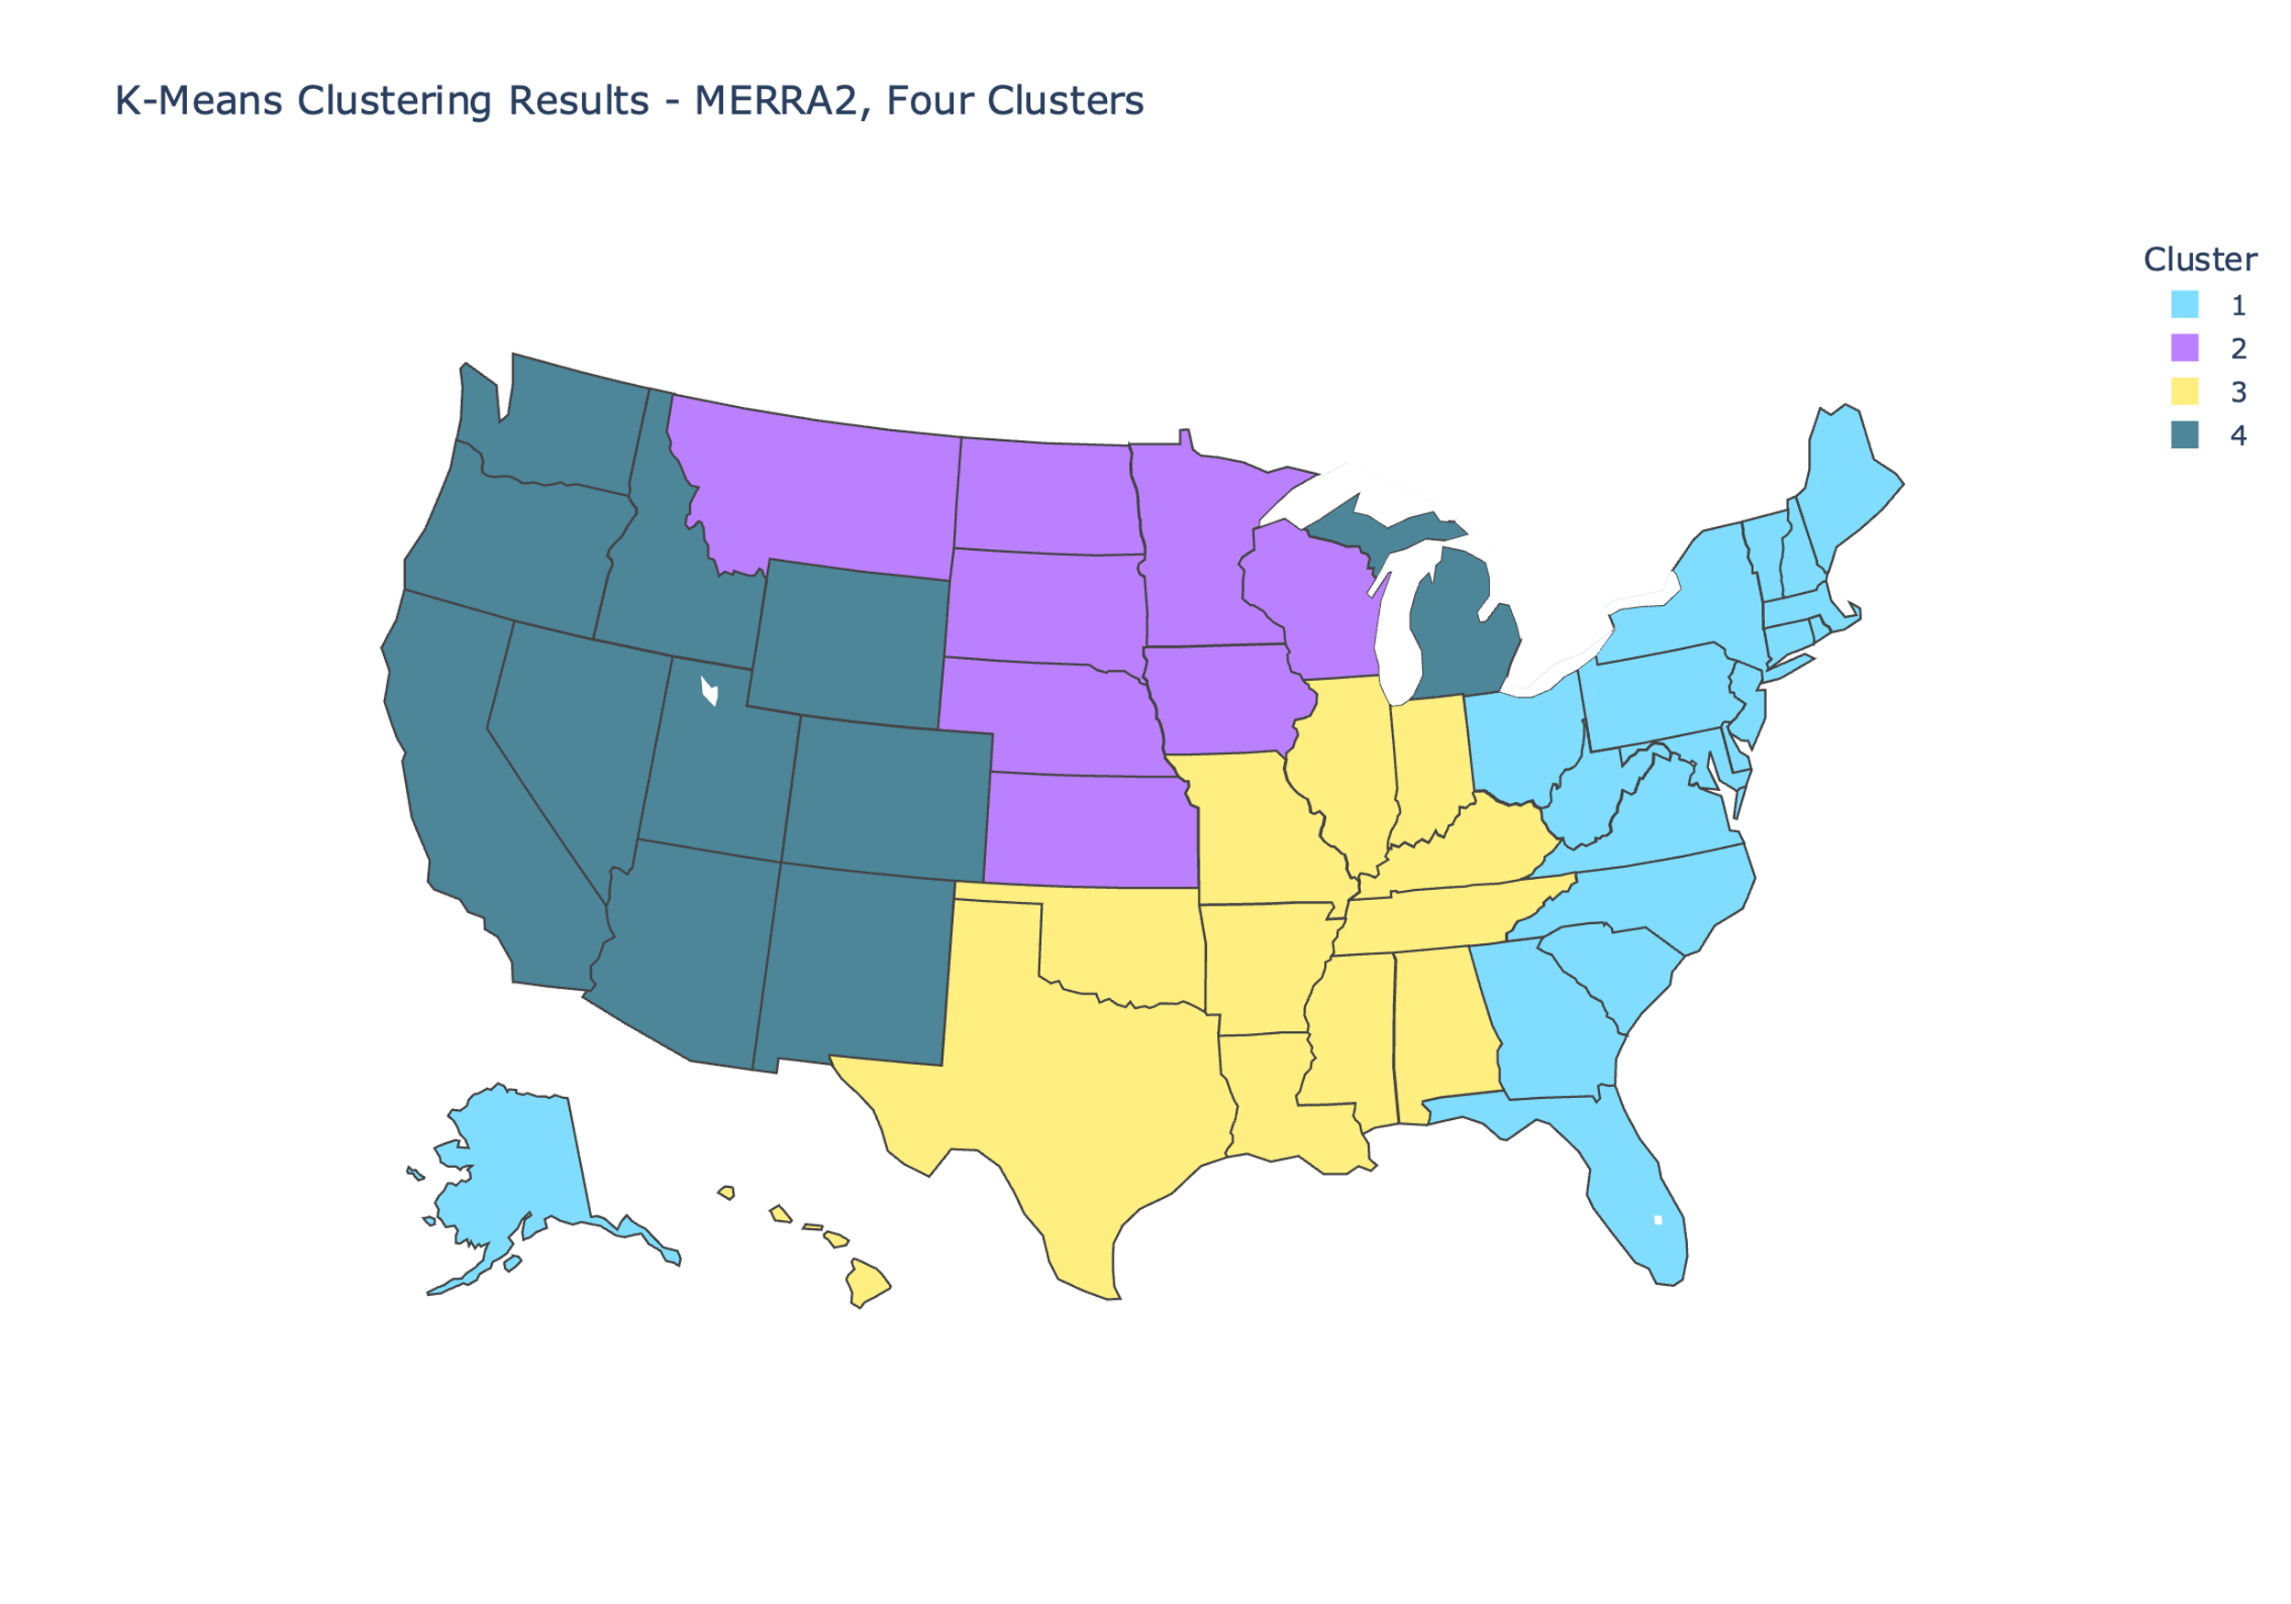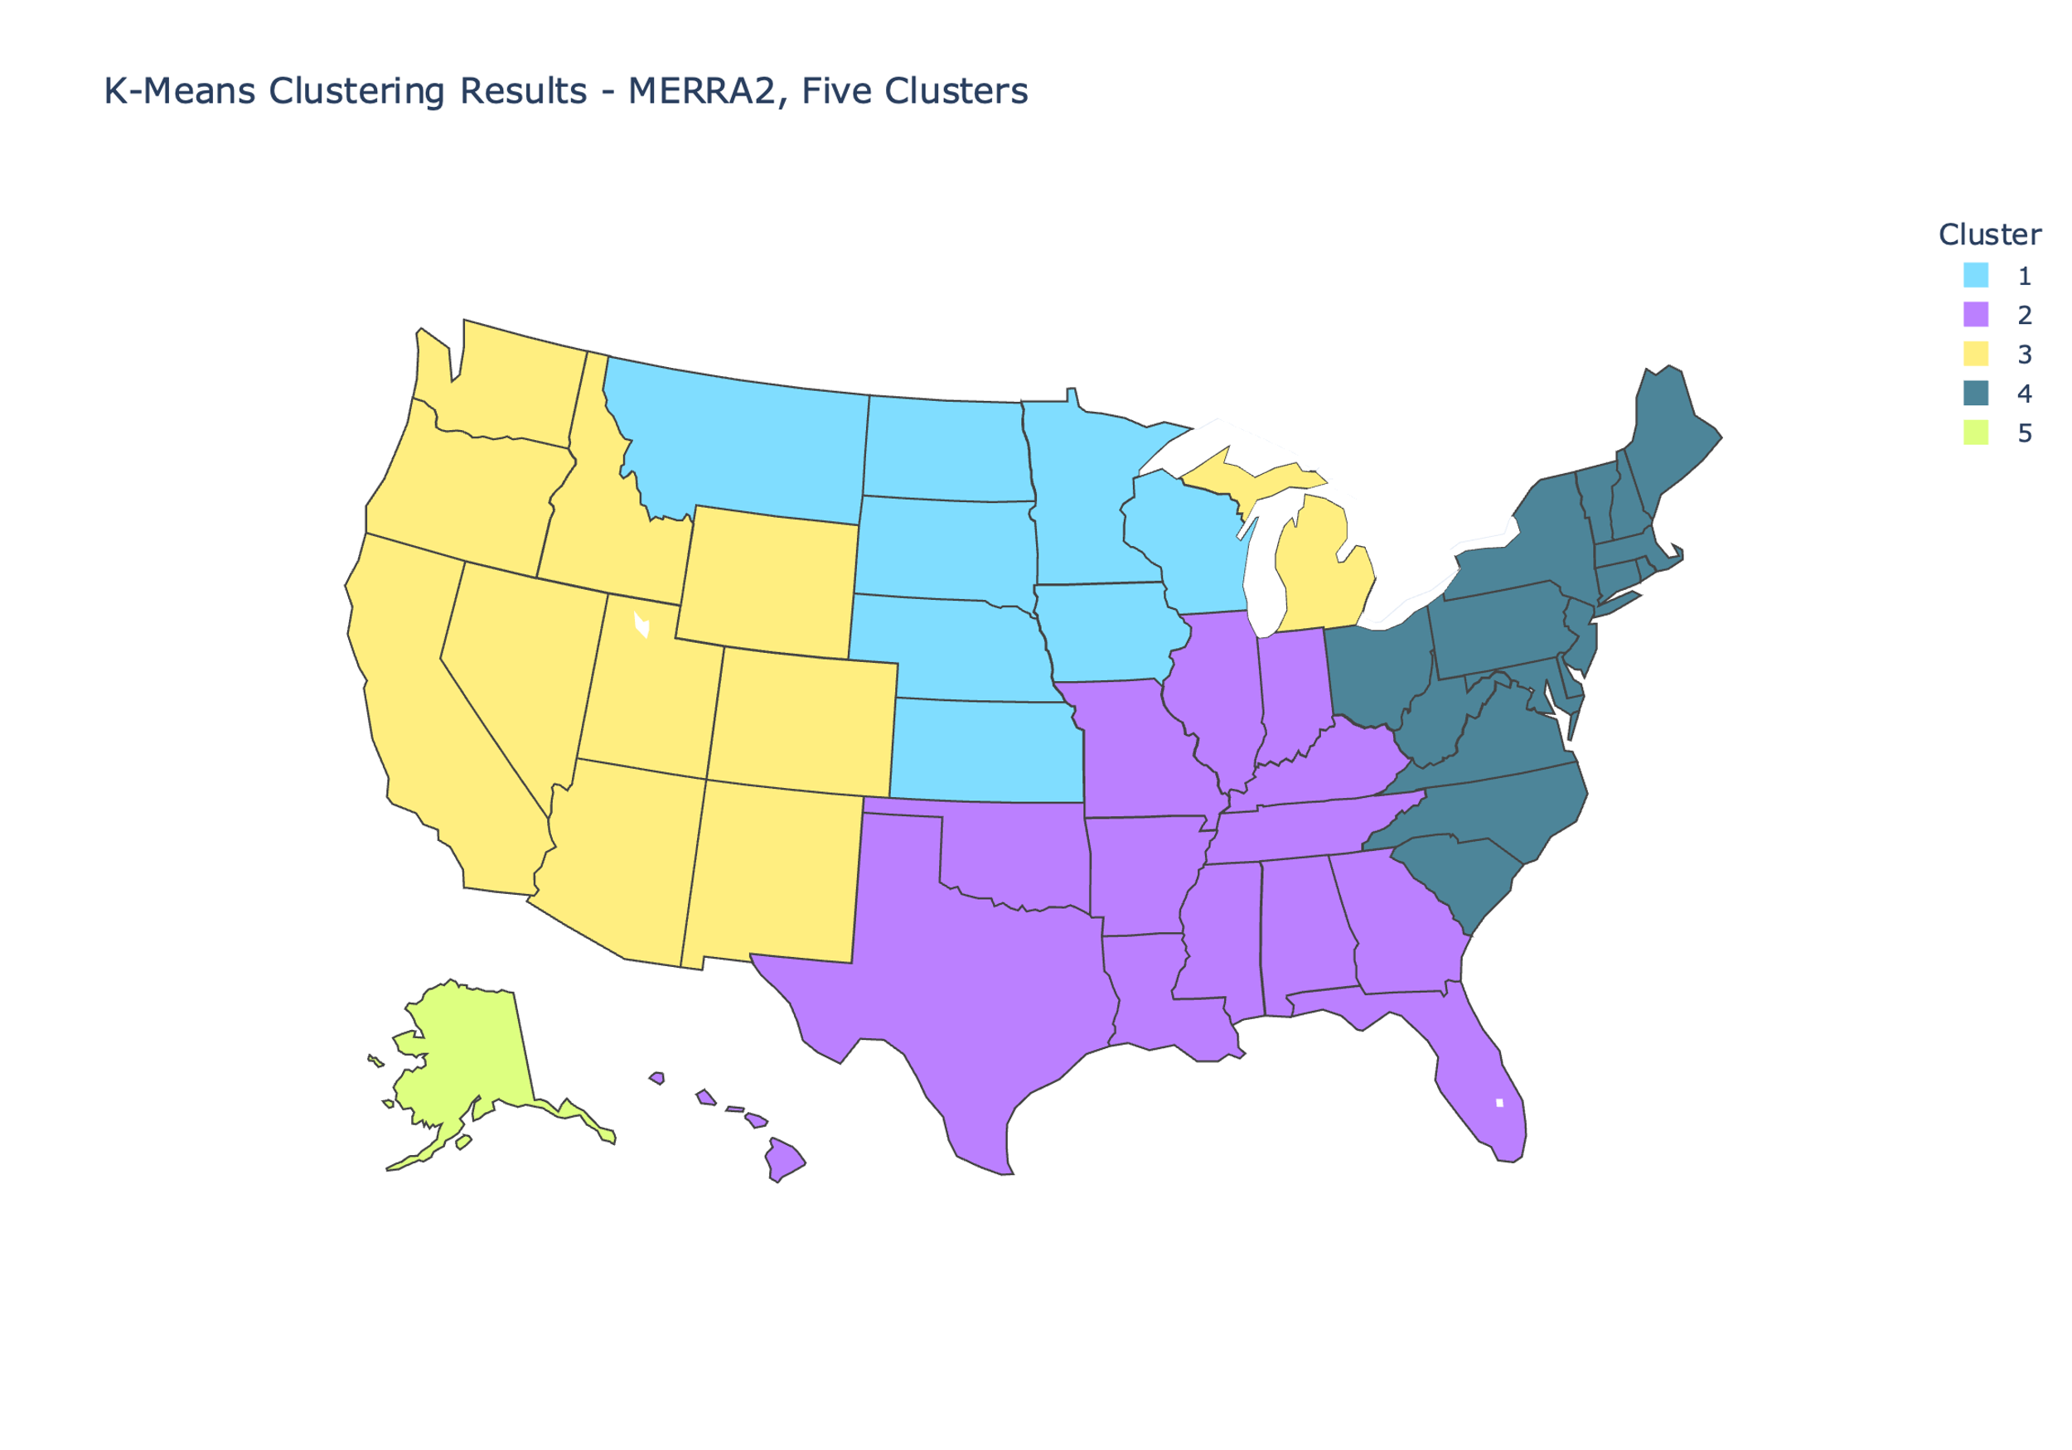

Supplementary Figure . Robustness of k-means clustering results to the number of clusters; the map to the left shows clustering results when the number of clusters is set to 4, and the map to the left shows the same when the number of clusters is set to 5.

Supplementary Figure 2 shows the clustering results for ERA5 data (using regression parameters from the MERRA2 timeframe, 1980-2022) with 4, 5 and 6 clusters.

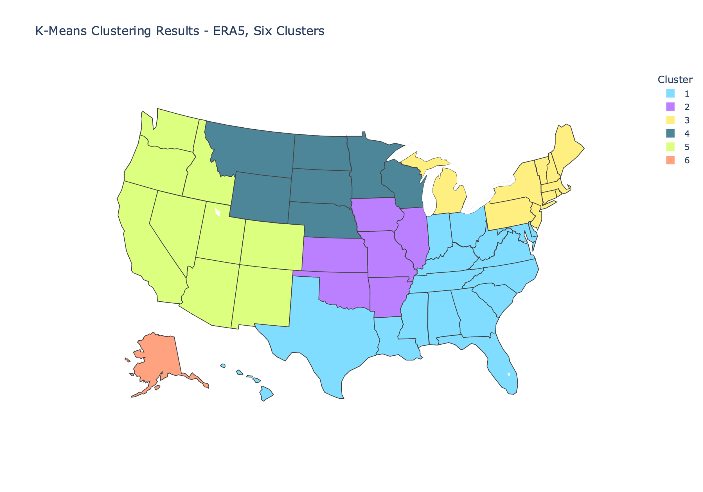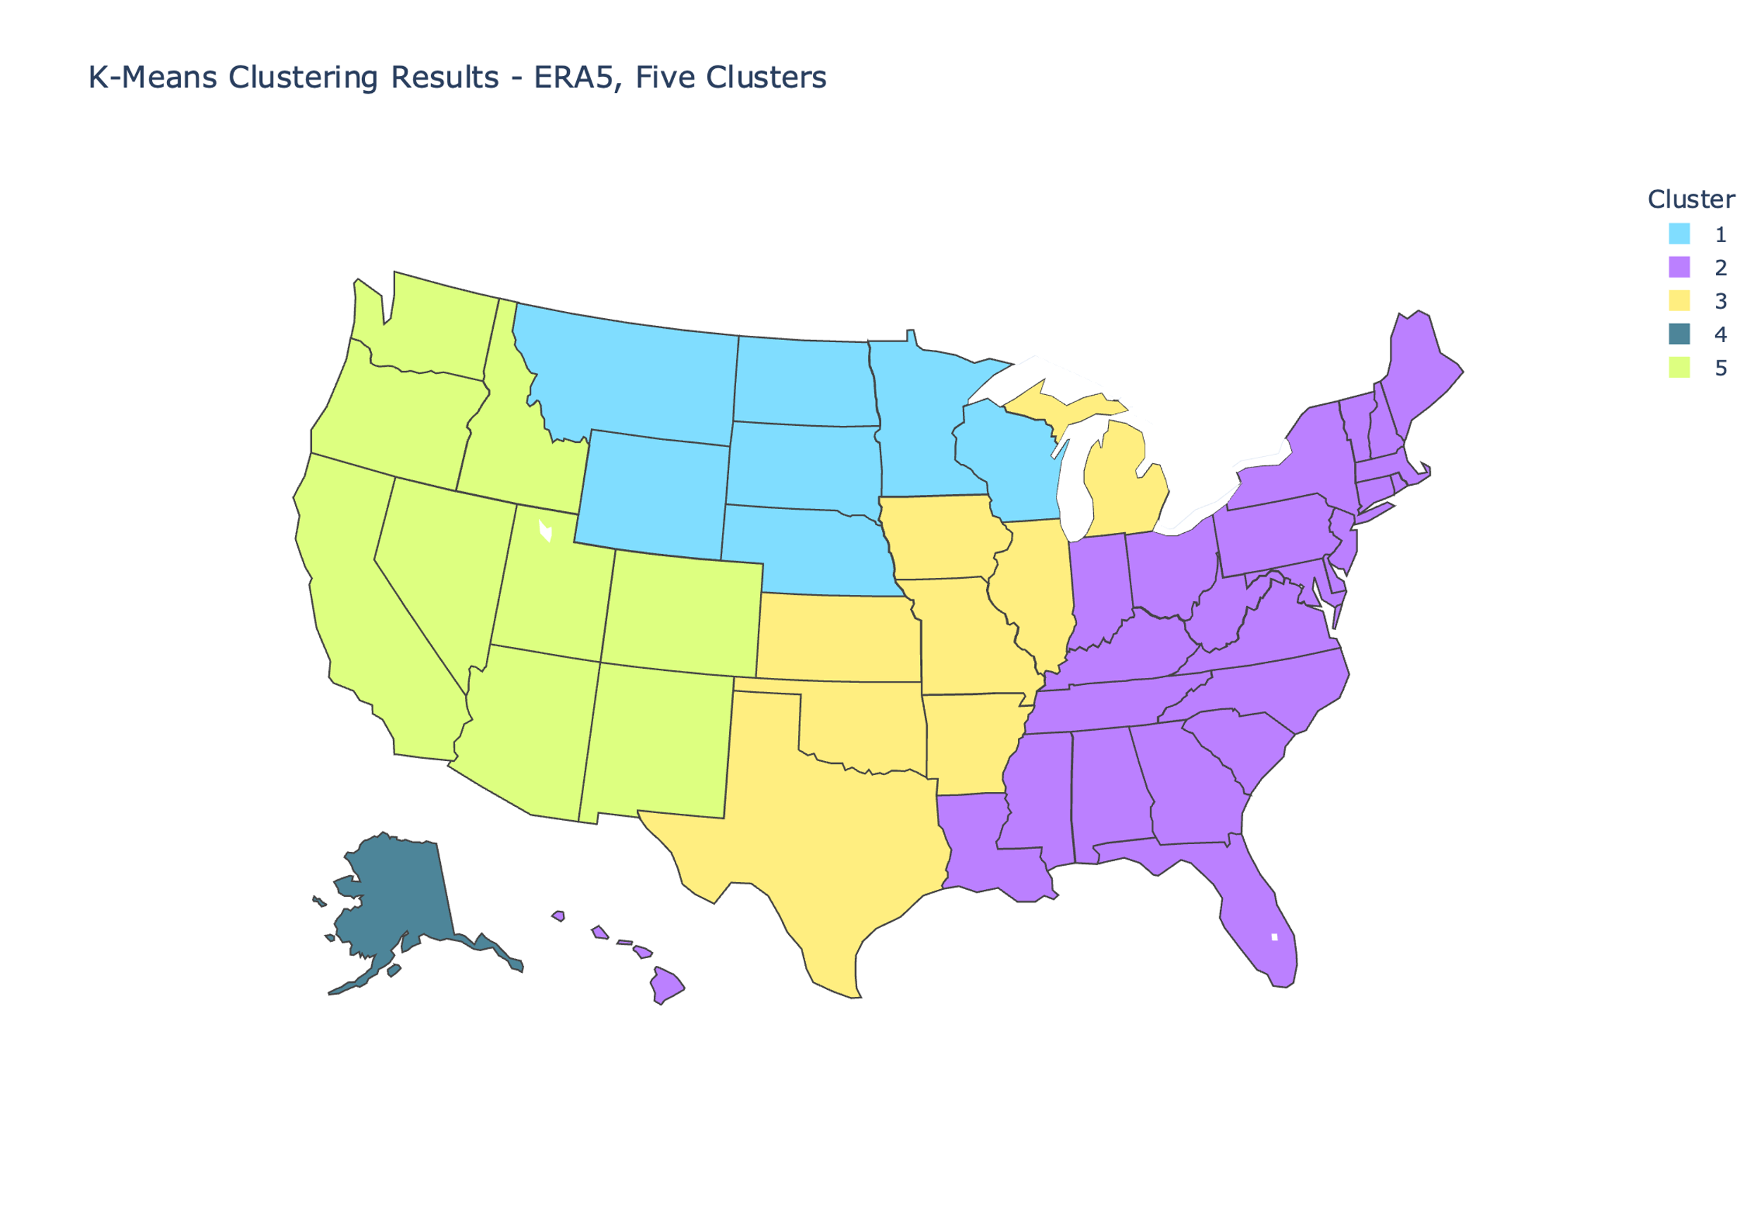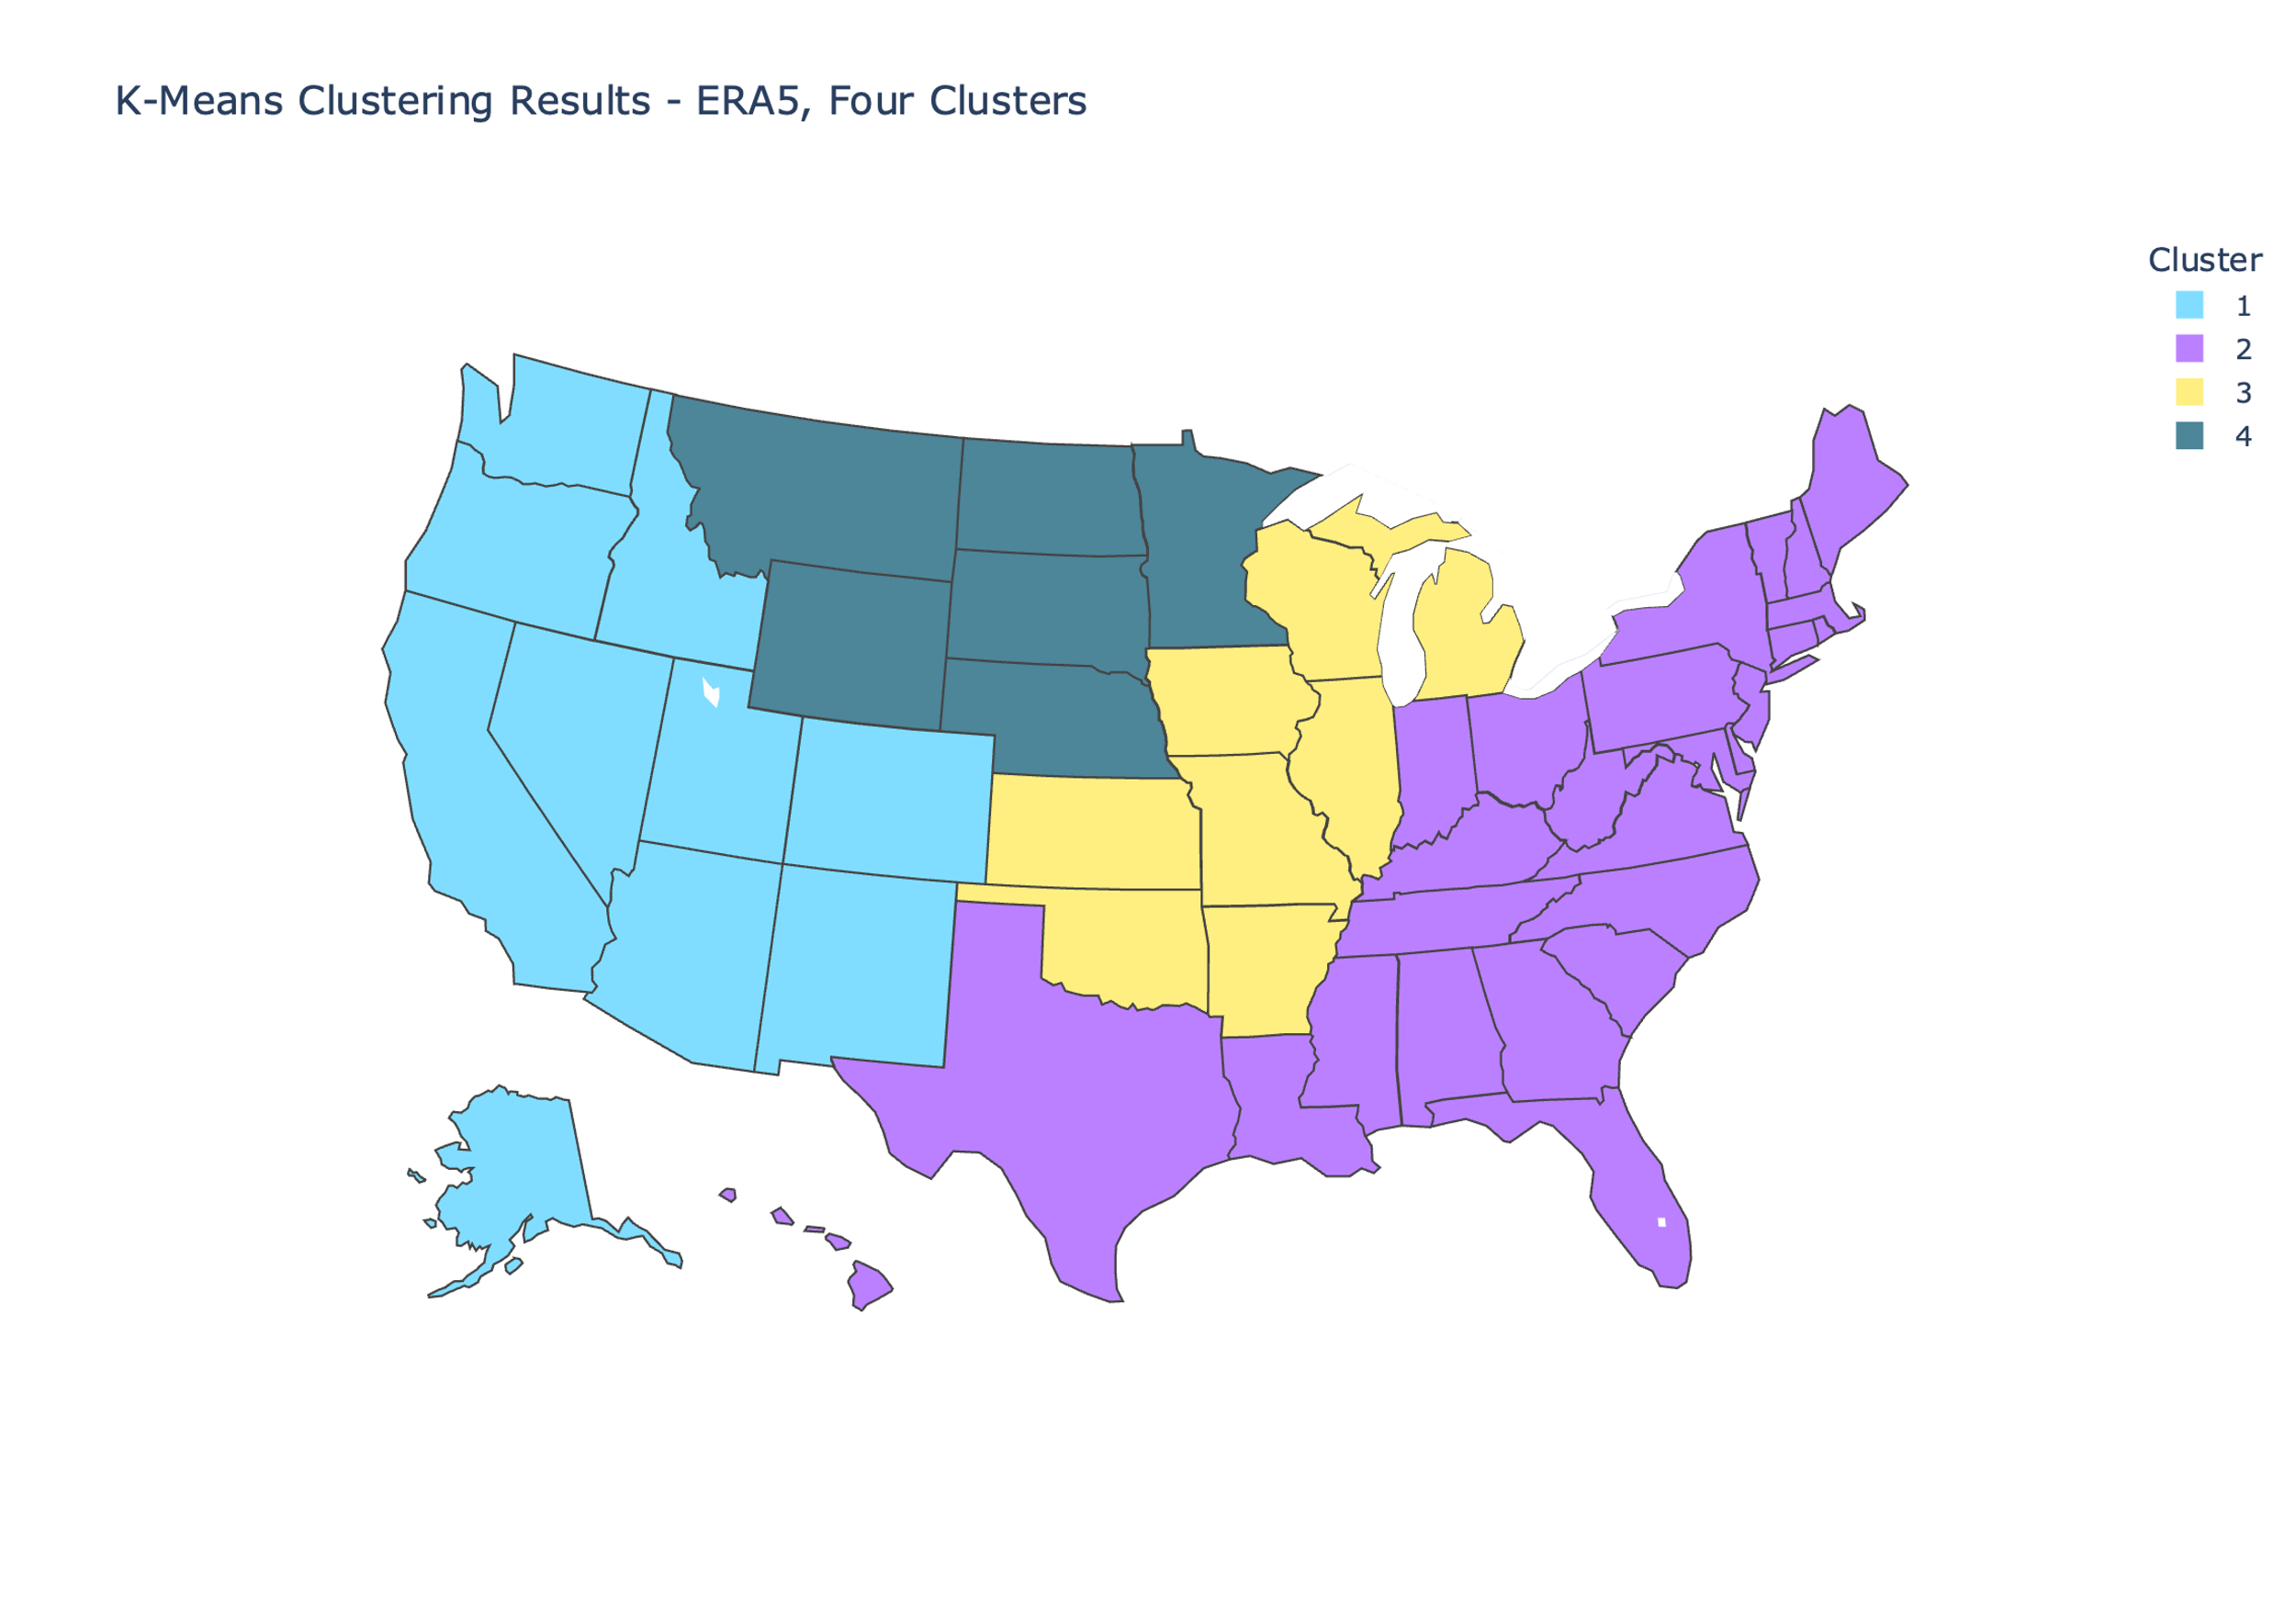

Supplementary Figure . Repeating the k-means clustering analysis with ERA5 data for purposes of comparison with MERRA2 clustering results. The same parameters for the k-means algorithm (k-means++ initialization with 10 initial sets of cluster centroids) was used.

### Regression Validations

The regression validation of MERRA2 data is given in Supplementary Figure 1. An 80/20 train/test split was used (data from 1980-2013 was used to train the linear regression model, and data from 2014-2022 was used to test the model and obtain the *R*2 score). Because of the limited sample size, the overall poor performance of the regression in predicting specific monthly-averaged daily max temperatures is unsurprising. The most well-supported conclusions that can be drawn are broader, relating not to any specific numbers, but to the magnitude and sign of the temperature change trends, given by Figure 1 and Figure 6. For thoroughness, we also present the validation of ERA5 data in Supplementary Figure 2, which contains a similar message.

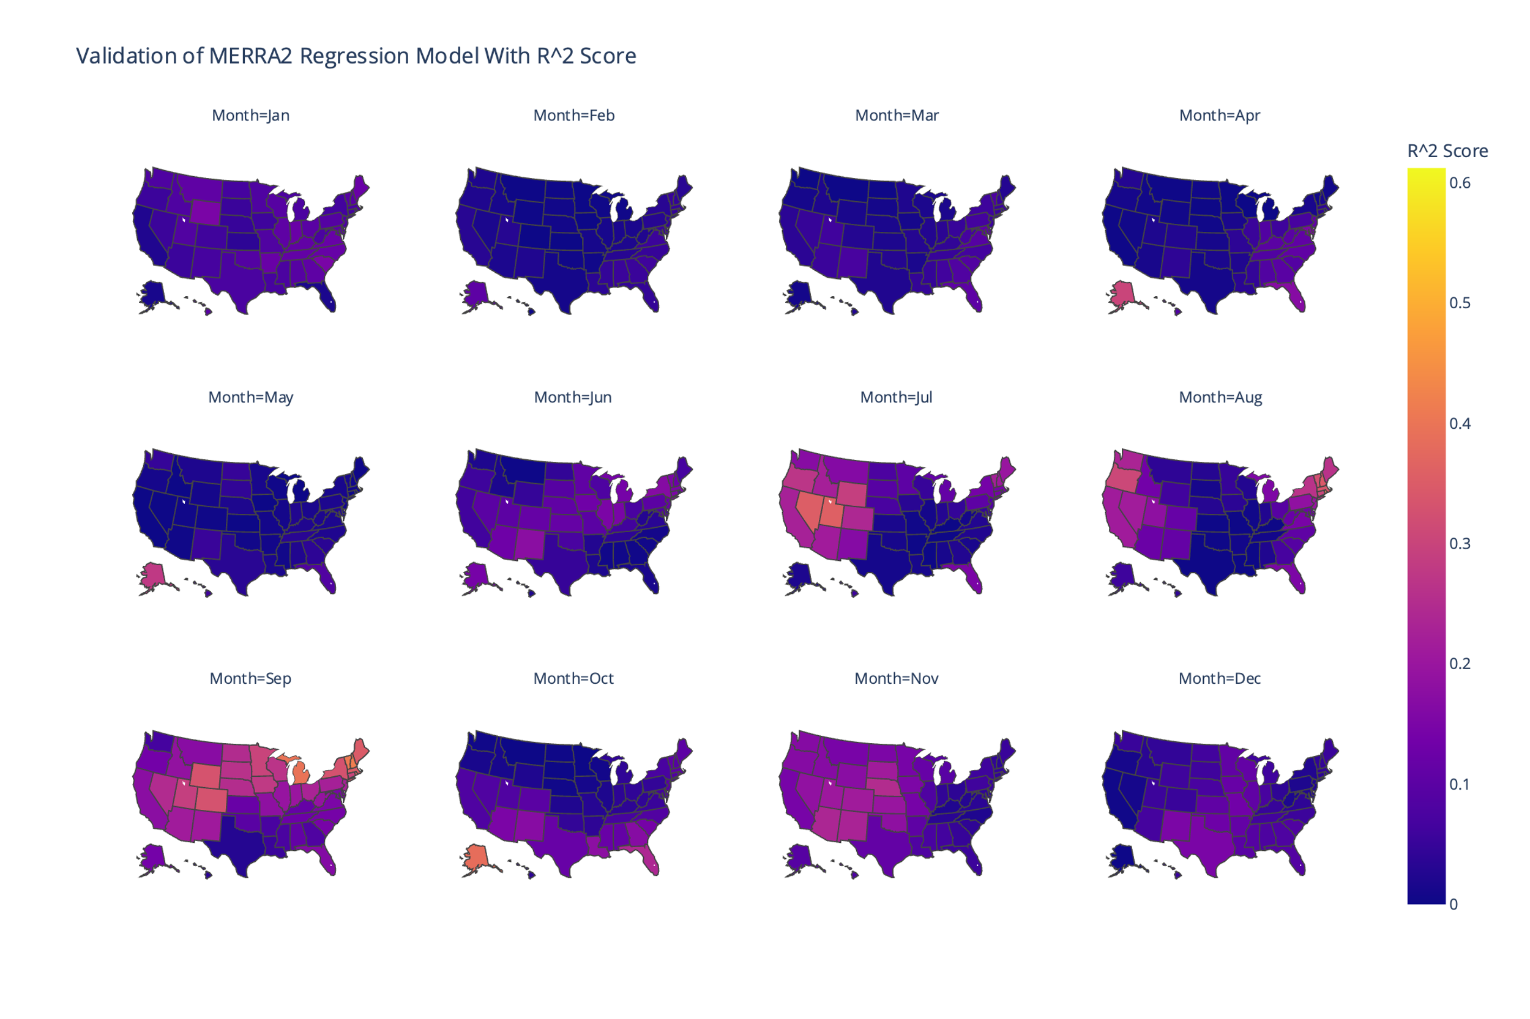

Supplementary Figure . R-squared scores for each state-month regression using MERRA2 data.

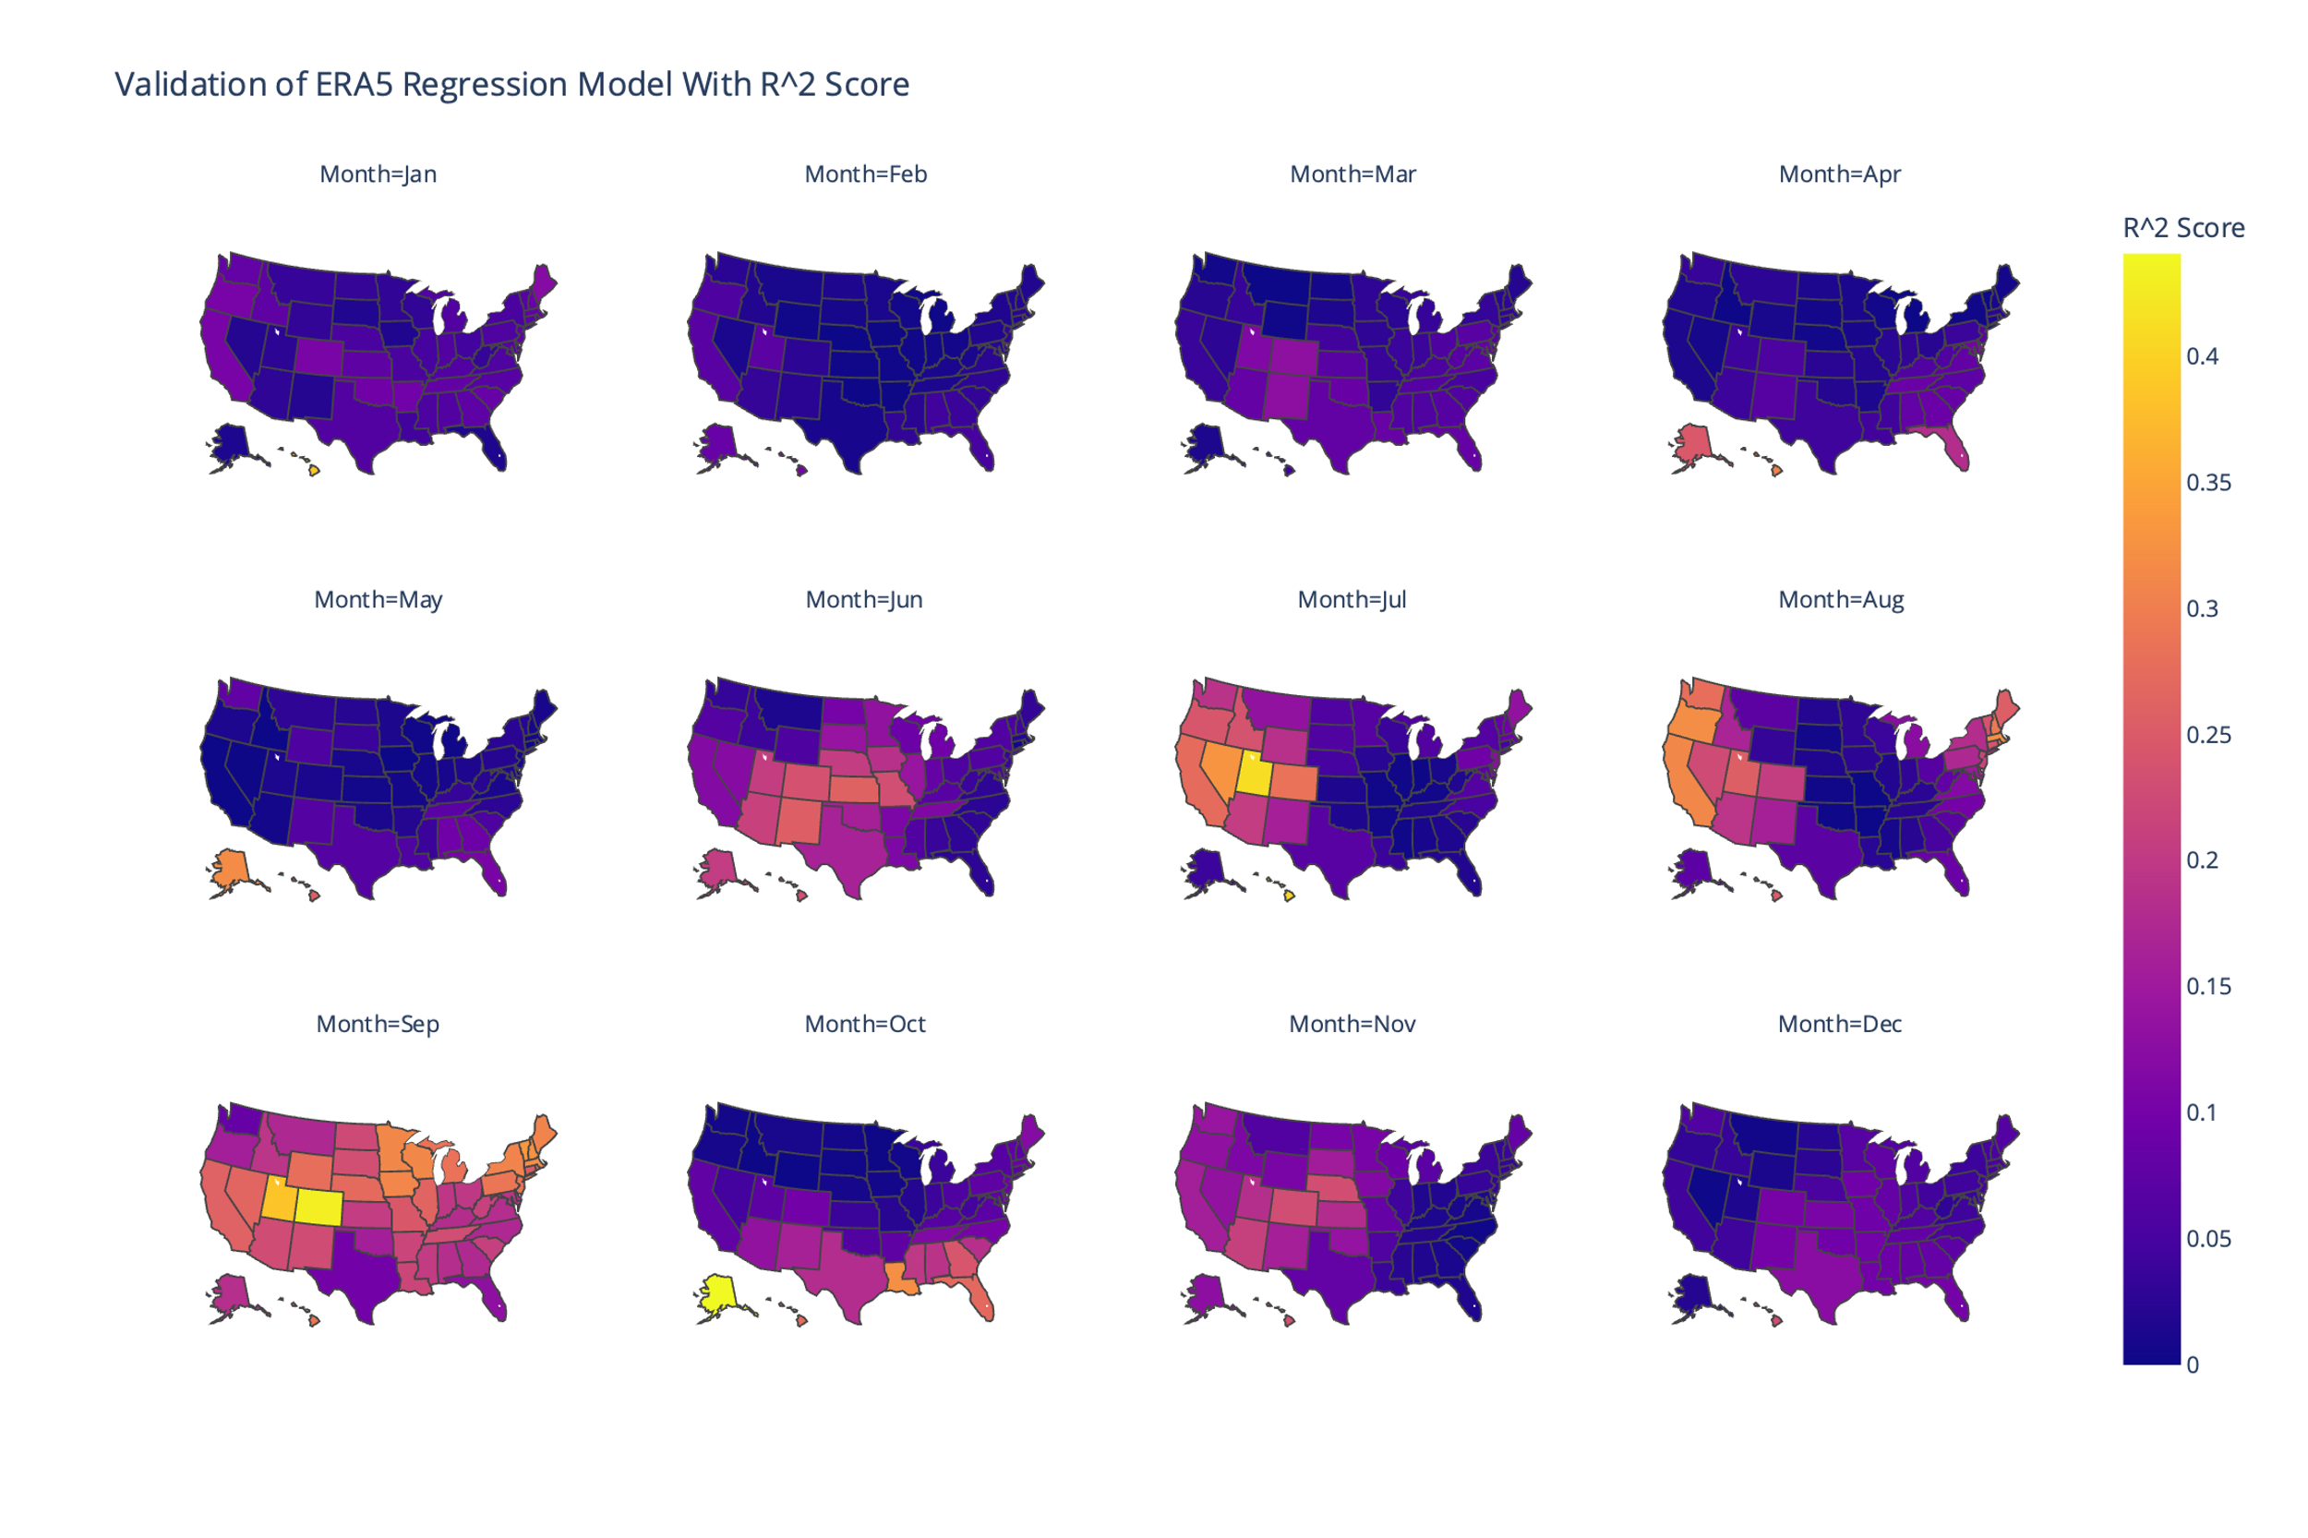

Supplementary Figure . R-squared scores for each state-month regression using ERA5 data over the MERRA2 time period, 1980-2022.

### ERA5 Regression Results Over the Full ERA5 Timeframe

The core dataset used in this study is the MERRA2 dataset, and the time period of data used from MERRA2 was 1980-2022. To conduct a fair comparison, when we used ERA5 data, we truncated the results from the original timeframe (1940-2023) to the MERRA2 timeframe. However, it is possible to look at the whole ERA5 timeframe – that is, to conduct regressions with data starting in 1940. The map given in Supplementary Figure () was generated using the same procedure as the previous such maps, but the years used in the regression are 1940-2023.

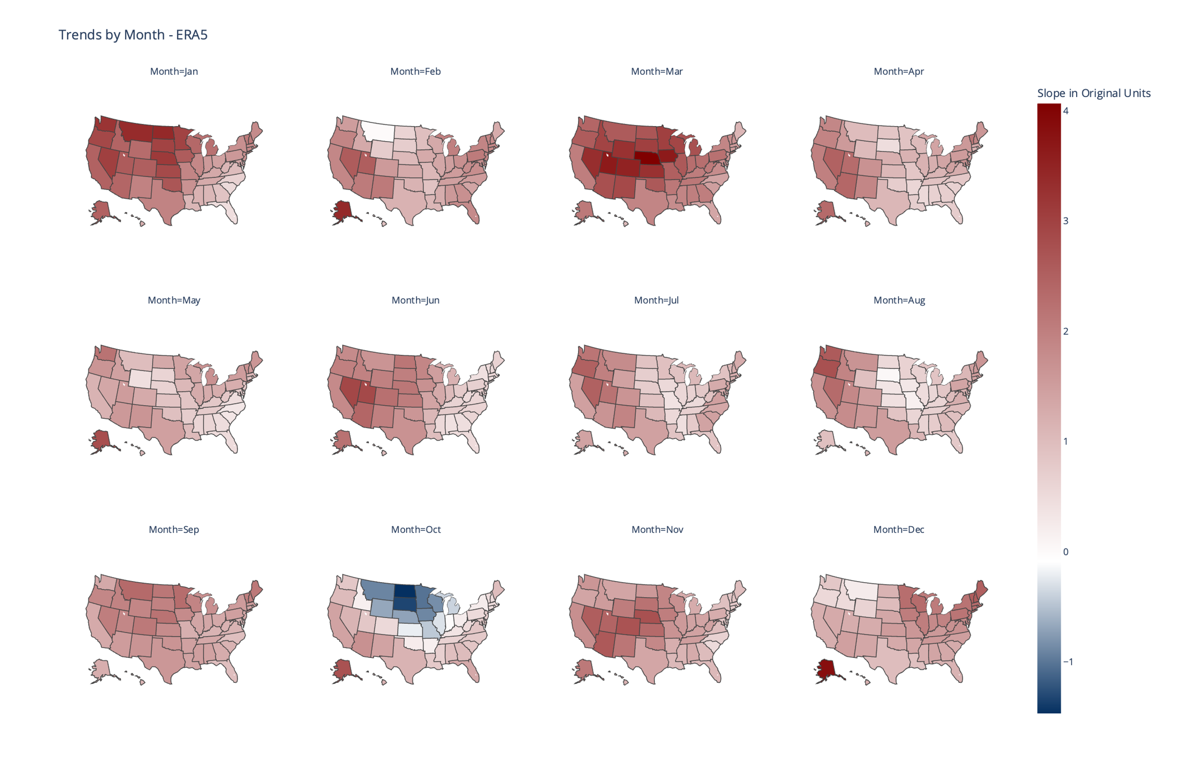

Supplementary Figure . Trends by state and month over the entire ERA5 time period, 1940-2023.

## Acknowledgements

* Popat for data
* Python packages
* Cite theil sen estimator

## References

Almazroui, Mansour, and Zekâi Şen. 2020. “Trend Analyses Methodologies in Hydro-Meteorological Records.” *Earth Systems and Environment* 4 (4): 713–38. https://doi.org/10.1007/s41748-020-00190-6.

Arthur, David, and Sergei Vassilvitskii. 2006. “K-Means++: The Advantages of Careful Seeding.” Techreport. Stanford. June 7, 2006. http://ilpubs.stanford.edu:8090/778/?ref=https://githubhelp.com.

Carvalho, M. J., P. Melo-Gonçalves, J. C. Teixeira, and A. Rocha. 2016. “Regionalization of Europe Based on a *K*-Means Cluster Analysis of the Climate Change of Temperatures and Precipitation.” *Physics and Chemistry of the Earth, Parts A/B/C*, 3rd International Conference on Ecohydrology, Soil and Climate Change, EcoHCC’14, 94 (August):22–28. https://doi.org/10.1016/j.pce.2016.05.001.

Collins, M., R. Knutti, J. Arblaster, J.-L. Dufresne, T. Fichefet, P. Friedlingstein, X. Gao, et al. 2013. “Chapter 12 - Long-Term Climate Change: Projections, Commitments and Irreversibility.” In , edited by IPCC. Cambridge: Cambridge University Press. http://www.climatechange2013.org/images/report/WG1AR5_Chapter12_FINAL.pdf.

Copernicus Climate Change Service (C3S) Climate Data Store (CDS). 2024. “ERA5 Post-Processed Daily-Statistics on Single Levels from 1940 to Present.” https://doi.org/10.24381/cds.4991cf48.

Dai, Shuwei, Martha Shulski, Kenneth Hubbard, and Eugene Takle. 2016. “A Spatiotemporal Analysis of Midwest US Temperature and Precipitation Trends during the Growing Season from 1980 to 2013.” *School of Natural Resources: Faculty Publications*, January. https://digitalcommons.unl.edu/natrespapers/626.

Fujiwara, Masatomo, Jonathon S. Wright, Gloria L. Manney, Lesley J. Gray, James Anstey, Thomas Birner, Sean Davis, et al. 2017. “Introduction to the SPARC Reanalysis Intercomparison Project (S-RIP) and Overview of the Reanalysis Systems.” *Atmospheric Chemistry and Physics* 17 (2): 1417–52. https://doi.org/10.5194/acp-17-1417-2017.

Gao, Xiang, C. Adam Schlosser, and Eric R. Morgan. 2018. “Potential Impacts of Climate Warming and Increased Summer Heat Stress on the Electric Grid: A Case Study for a Large Power Transformer (LPT) in the Northeast United States.” *Climatic Change* 147 (1–2): 107–18. https://doi.org/10.1007/s10584-017-2114-x.

García, Francisca C., Elvire Bestion, Ruth Warfield, and Gabriel Yvon-Durocher. 2018. “Changes in Temperature Alter the Relationship between Biodiversity and Ecosystem Functioning.” *Proceedings of the National Academy of Sciences* 115 (43): 10989–94. https://doi.org/10.1073/pnas.1805518115.

Global Modeling and Assimilation Office (GMAO). n.d. “Modern-Era Retrospective Analysis for Research and Applications, Version 2.” https://doi.org/10.5067/9SC1VNTWGWV3.

Grotjahn, Richard, and Jonathan Huynh. 2018. “Contiguous US Summer Maximum Temperature and Heat Stress Trends in CRU and NOAA Climate Division Data plus Comparisons to Reanalyses.” *Scientific Reports* 8 (1): 11146. https://doi.org/10.1038/s41598-018-29286-w.

Hayhoe, Katharine, Cameron Wake, Bruce Anderson, Xin-Zhong Liang, Edwin Maurer, Jinhong Zhu, James Bradbury, Art DeGaetano, Anne Marie Stoner, and Donald Wuebbles. 2008. “Regional Climate Change Projections for the Northeast USA.” *Mitigation and Adaptation Strategies for Global Change* 13 (5): 425–36. https://doi.org/10.1007/s11027-007-9133-2.

Kim, Yesuel, and Youngchul Kim. 2023. “Global Regionalization of Heat Environment Quality Perception Based on K-Means Clustering and Google Trends Data.” *Sustainable Cities and Society* 96 (September):104710. https://doi.org/10.1016/j.scs.2023.104710.

King, Andrew D. 2019. “The Drivers of Nonlinear Local Temperature Change under Global Warming.” *Environmental Research Letters* 14 (6): 064005. https://doi.org/10.1088/1748-9326/ab1976.

Lee, Hoesung, Katherine Calvin, Dipak Dasgupta, Gerhard Krinmer, Aditi Mukherji, Peter Thorne, Christopher Trisos, et al. 2023. “Synthesis Report of the IPCC Sixth Assessment Report (AR6), Longer Report. IPCC.” Monograph. Intergovernmental Panel on Climate Change (IPCC). 2023. https://mural.maynoothuniversity.ie/17733/.

Mascioli, Nora R, Michael Previdi, Arlene M Fiore, and Mingfang Ting. 2017. “Timing and Seasonality of the United States ‘Warming Hole.’” *Environmental Research Letters* 12 (3): 034008. https://doi.org/10.1088/1748-9326/aa5ef4.

Meehl, Gerald A., Julie M. Arblaster, and Grant Branstator. 2012. “Mechanisms Contributing to the Warming Hole and the Consequent U.S. East–West Differential of Heat Extremes,” September. https://doi.org/10.1175/JCLI-D-11-00655.1.

Meehl, Gerald A., Julie M. Arblaster, and Christine T. Y. Chung. 2015. “Disappearance of the Southeast U.S. ‘Warming Hole’ with the Late 1990s Transition of the Interdecadal Pacific Oscillation.” *Geophysical Research Letters* 42 (13): 5564–70. https://doi.org/10.1002/2015GL064586.

Meehl, Gerald A., and Claudia Tebaldi. 2004. “More Intense, More Frequent, and Longer Lasting Heat Waves in the 21st Century.” *Science* 305 (5686): 994–97. https://doi.org/10.1126/science.1098704.

Molina, M. O., C. Gutiérrez, M. Ortega, and E. Sánchez. 2023. “Summer Heatwaves, Wind Production and Electricity Demand in Southern Europe: Climatic Conditions and Impacts.” *Environmental Research Communications* 5 (8): 085005. https://doi.org/10.1088/2515-7620/acec37.

Partridge, T. F., J. M. Winter, E. C. Osterberg, D. W. Hyndman, A. D. Kendall, and F. J. Magilligan. 2018. “Spatially Distinct Seasonal Patterns and Forcings of the U.S. Warming Hole.” *Geophysical Research Letters* 45 (4): 2055–63. https://doi.org/10.1002/2017GL076463.

Partridge, Trevor F, Jonathan M Winter, Lin Liu, Anthony D Kendall, Bruno Basso, and David W Hyndman. 2019. “Mid-20th Century Warming Hole Boosts US Maize Yields.” *Environmental Research Letters* 14 (11): 114008. https://doi.org/10.1088/1748-9326/ab422b.

Powell, Emily J., and Barry D. Keim. 2015. “Trends in Daily Temperature and Precipitation Extremes for the Southeastern United States: 1948–2012,” February. https://doi.org/10.1175/JCLI-D-14-00410.1.

Sathiaraj, D., X. Huang, and J. Chen. 2019. “Predicting Climate Types for the Continental United States Using Unsupervised Clustering Techniques.” *Environmetrics* 30 (4): e2524. https://doi.org/10.1002/env.2524.

Scherer, Martin, and Noah S. Diffenbaugh. 2014. “Transient Twenty-First Century Changes in Daily-Scale Temperature Extremes in the United States.” *Climate Dynamics* 42 (5): 1383–1404. https://doi.org/10.1007/s00382-013-1829-2.

Tavakol, Ameneh, Vahid Rahmani, and John Harrington. 2020. “Evaluation of Hot Temperature Extremes and Heat Waves in the Mississippi River Basin.” *Atmospheric Research* 239 (July):104907. https://doi.org/10.1016/j.atmosres.2020.104907.

Wheeler, Timothy R, Peter Q Craufurd, Richard H Ellis, John R Porter, and P. V Vara Prasad. 2000. “Temperature Variability and the Yield of Annual Crops.” *Agriculture, Ecosystems & Environment* 82 (1): 159–67. https://doi.org/10.1016/S0167-8809(00)00224-3.

Zittis, George, Georgia Lazoglou, Panos Hadjinicolaou, and Jos Lelieveld. 2024. “Emerging Extreme Heat Conditions as Part of the New Climate Normal.” *Theoretical and Applied Climatology* 155 (1): 143–50. https://doi.org/10.1007/s00704-023-04605-y.